NETWORK TRAFFIC ANALYSIS

**Cyber-security**

SAI GANAPATHI ENGINEERING COLLEGE

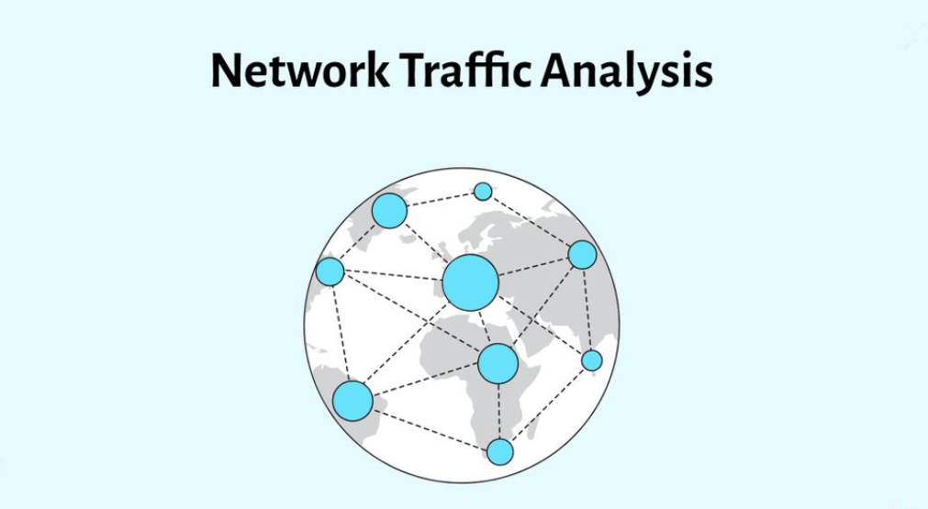

PROJECT

*Internship submitted in partial fulfillment’s of the requirements for the award of degree of*

Bachelor of Technology

In

Computer Science And Engineering

By

Team Id : LTVIP2023TMID07006

Team Leader : Bera Praveenkumar

Team member : Anupoju Nagamaniteja

Team member : Peruri Hari

Team member : Nambala Vijaylokesh

Team member : Akkireddy Harshavardan

 Under the esteemed guidance of

Department of Computer Science And Engineering

SAI GANAPATHI ENGINEERING COLLEGE

Approved by AICTE. New Delhi, Affiliated to JNTU GURAJADA,VIZAYANAGARAM

GIDIJALA(V), ANANDAPURAM(M),VISAKHAPATNAM-531173.AP 2022-2023

Task 1

### 1. *Information gathering*

1.1  Email footprint analysis:

Email footprint analysis refers to the process of examining and evaluating an individual or organization's digital trail left through their email communications. It involves collecting, analyzing, and interpreting various metadata and content from emails to gain insights into patterns, behavior, and relationships. This analysis can be used for various purposes, such as cybersecurity investigations, digital forensics, marketing research, and more.

Here are some aspects typically considered in email footprint analysis:

1. Email Headers: Analyzing email headers can reveal valuable information such as the sender's IP address, email client, server paths, and timestamps. This information can help in identifying potential sources of phishing attacks or email spoofing.

2. Sender and Recipient Analysis: Studying the frequency and volume of email exchanges between different senders and recipients can provide insights into communication patterns and relationships. It can also help identify key contacts or suspicious interactions.

3. Content Analysis: Examining the content of emails can offer information about topics of interest, potential risks, or even sensitive information leaks. Natural language processing techniques can be used to extract relevant data from email content.

4. Attachment Analysis: Checking attachments for malware or suspicious files can be an essential part of email footprint analysis, especially in cybersecurity investigations.

5. Timestamps and Time Zones: Analyzing the timestamps and time zones of emails can help establish the location of email senders or uncover anomalies in communication patterns.

6. Email Forwarding and BCC Analysis: Tracking email forwarding and BCC (blind carbon copy) recipients can be crucial in understanding how information is disseminated within or outside an organization.

7. Email Volume and Traffic Patterns: Monitoring the volume and frequency of incoming and outgoing emails over time can help detect abnormal activity or potential email-based attacks.

8. Email Authentication Records: Analyzing SPF (Sender Policy Framework), DKIM (DomainKeys Identified Mail), and DMARC (Domain-based Message Authentication, Reporting, and Conformance) records can help verify the legitimacy of emails and identify spoofed or fraudulent messages.

9. Geolocation Data: If available, geolocation data associated with email communications can provide additional context, especially in cases of suspicious or malicious activity.

STEP BY STEP PROCESS FOR EMAIL FOOTPRINTING ANALYSIS:

Step 1 :

* Open your Gmail ,GO through the spam mails box and open it .
* In spam folder where you can find many spam mails .
* TO perform an footprinting ,open any spam mail which you want perform.



Step 2 :

* Now , select the spam mail to perform email footprint analysis .

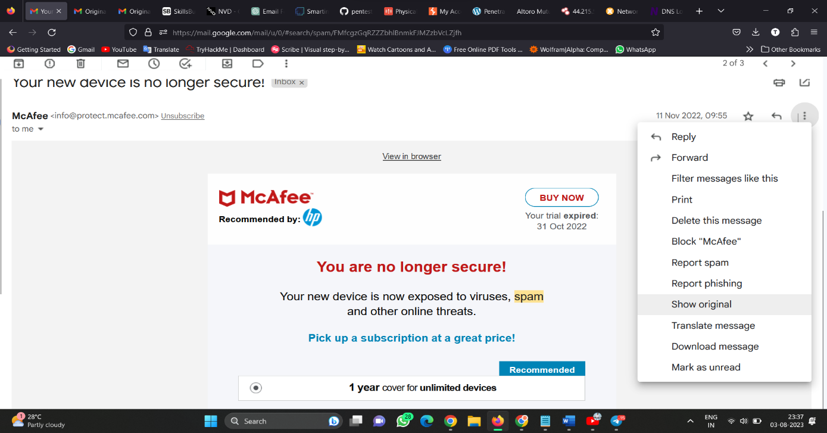

* As we see here the basic details of the Mcafee.com.

Step 3:

* In spam mail you’ll find show original.



* Now click on the show original therefore you’ll redirect to new tab

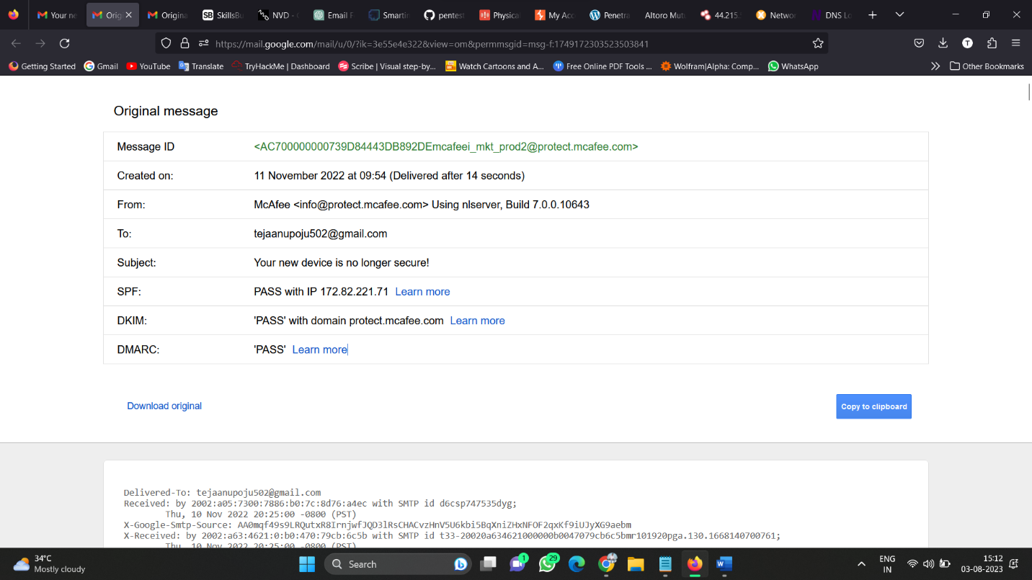

* You’ll find some code type below the original message in that you have to find “receive form”
* After finding receive form you’ll find IP address over there copy it.
* Open another new tab and search for whois IP lookup and open the first result of your search paste the IP address over there 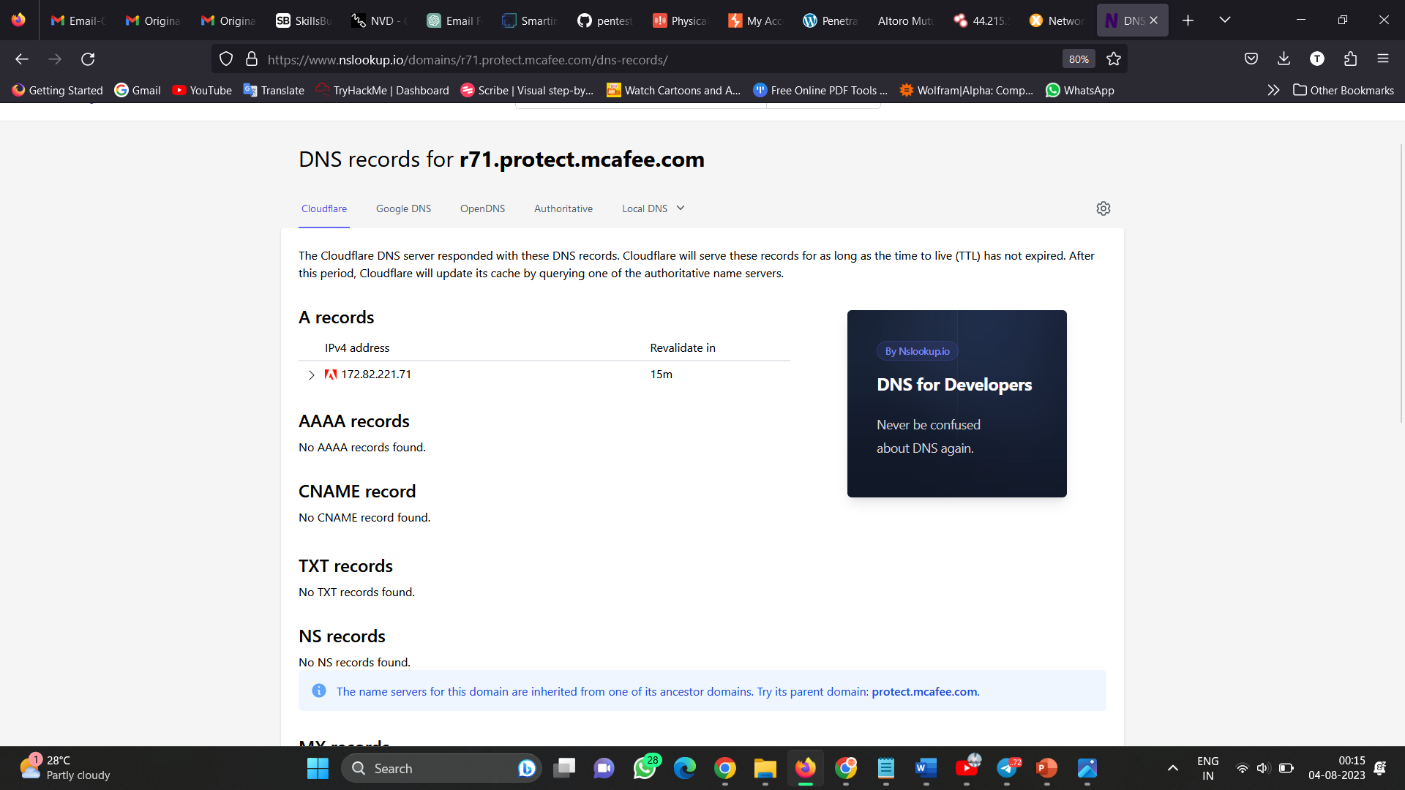
* In above you’ll find the ip address range from 172.82.221.71
* And also the mail is form MS-820.

By this you’ll find the information by email footprint analysis.

1.2  DNS information gathering:

* Passive mode
  + DNS Enumeration
  + OSINT
* Offensive mode
  + spider websites
* Tools
  + recon-ng
  + dnsrecon
  + theHarvester

## Passive mode

### DNS Enumeration

**DNS enumeration** is the process of locating all the DNS servers and their corresponding records for an organization. A company may have both internal and external DNS servers that can yield information such as usernames, computer names, and IP addresses of potential target systems. There are a lot of tools that can be used to gain information for performing DNS enumeration. The examples of tool that can be used for DNS enumeration are NSlookup, DNSstuff, American Registry for Internet Numbers (ARIN), and Whois. To enumerate DNS, you must have understanding about DNS and how it works.

You must have knowledge about DNS records. The list of DNS record provides an overview of types of resource records (database records) stored in the zone files of the Domain Name System (DNS). The DNS implements a distributed, hierarchical, and redundant database for information associated with Internet domain names and addresses. In these domain servers, different record types are used for different purposes. The following list describes the common DNS record types and their use:

| DNS Record types | methods | description |
| --- | --- | --- |
| dns query | A | *Address record*, Returns a 32-bit IPv4 address, most commonly used to map hostnames to an IP address of the host, but it is also used for DNSBLs, storing subnet masks in RFC 1101, etc. |
| dns query | CNAME | *Canonical name record*, Alias of one name to another: the DNS lookup will continue by retrying the lookup with the new name. |
| dns query | AAAA | *IPv6 address record*, Returns a 128-bit IPv6 address, most commonly used to map hostnames to an IP address of the host. |
| dns query | MX | *Mail exchange record*, Maps a domain name to a list of message transfer agents for that domain |
| dns query | NS | *Name server record*, Delegates a DNS zone to use the given authoritative name servers |
| dns query | SOA | *zone of authority record*, Specifies authoritative information about a DNS zone, including the primary name server, the email of the domain administrator, the domain serial number, and several timers relating to refreshing the zone. |
| dns query | SPF | *Sender Policy Framework*, a simple email-validation system designed to detect email spoofing by providing a mechanism to allow receiving mail exchangers to check that incoming mail from a domain comes from a host authorized by that domain's administrators. |
| dns query | TXT | *Text record*, Originally for arbitrary human-readable text in a DNS record. |
| dns query | PTR | *Pointer record*, Pointer to a canonical name. Unlike a CNAME, DNS processing stops and just the name is returned. The most common use is for implementing reverse DNS lookups, but other uses include such things as DNS-SD. |
| dns query | SRV | *Service locator*, Generalized service location record, used for newer protocols instead of creating protocol-specific records such as MX. |
| dns query | NSEC | *Next Secure record*, Part of DNSSEC—used to prove a name does not exist. Uses the same format as the (obsolete) NXT record. |
| dns query | AXFR | *Authoritative Zone Transfer*, Transfer entire zone file from the master name server to secondary name servers. DNS Zone Transfer is typically used to replicate DNS data across a number of DNS servers, or to back up DNS files. A user or server will perform a specific zone transfer request from a ―name server.‖ If the name server allows zone transfers to occur, all the DNS names and IP addresses hosted by the name server will be returned in human-readable ASCII text. |

### OSINT

| OSINT | Category | Description |
| --- | --- | --- |
| OSInt | Google | Spider domains from Google pages with domain:demo.com |
| OSInt | Bing | Spider domains from Bing pages with domain:demo.com |
| OSInt | Yahoo | Spider domains from Yahoo with domain:demo.com |
| OSInt | Baidu | Spider domains from Baidu with domain:demo.com |
| OSInt | Netcraft | Spider domains from netcraft searchdns pages |
| OSInt | Github | Spider domain from github pages |
| OSInt | Shodan | Search domains from Shodan |
| OSInt | Censys | Search domains from censys |
| OSInt | ZoomEye | Search domains from ZoomEye |

## Offensive mode

| **offensive mode** | **methods** | **description** |
| --- | --- | --- |
| Websites | Spider default page | Scan default pages and spider domains |
| Websites | Certificates | Scan domains certificates |

## Tools

| **recon-ng Command** | **Description** |
| --- | --- |
| use recon/domains-hosts/baidu\_site | Search domains with baidu |
| use recon/domains-hosts/bing\_domain\_api | Search domains with bing api |
| use recon/domains-hosts/bing\_domain\_web | Search domains from bing web pages. |
| use recon/domains-hosts/brute\_hosts | Bruteforce subdomains |
| use recon/domains-hosts/google\_site\_api | Search domains with google api |
| use recon/domains-hosts/google\_site\_web | Search domains from google web pages. |
| use recon/domains-hosts/netcraft | Search domains from netcraft pages. |

| **dnsrecon Command** | **Description** |
| --- | --- |
| dnsrecon -n 8.8.8.8 -d demo.com | Pleaes use a valid dns server in order to avoid dns fake. |
| dnsrecon -d demo.com -t std | SOA, NS, A, AAAA, MX and SRV if AXRF on the NS servers fail. |
| dnsrecon -d demo.com -t rvl | Reverse lookup of a given CIDR or IP range. |
| dnsrecon -d demo.com -t brt -D /path/to/subdomains.wd | Brute force domains and hosts using a given dictionary. |
| dnsrecon -d demo.com -t brt -D /path/to/subdomains.wd --iw | Brute force domains and hosts using a given dictionary. Continue brute forcing a domain even if a wildcard records are discovered. |
| dnsrecon -d demo.com -t srv | SRV records |
| dnsrecon -d demo.com -t axfr | Test all NS servers for a zone transfer. |
| dnsrecon -d demo.com -t goo | Perform Google search for subdomains and hosts. |
| dnsrecon -d demo.com -t tld | Remove the TLD of given domain and test against all TLDs registered in IANA. |
| dnsrecon -d demo.com -t zonewalk | Perform a DNSSEC zone walk using NSEC records. |
| dnsrecon -d demo.com --db /path/to/results.sqlite | Save results in a sqlite file. |
| dnsrecon -d demo.com --xml /path/to/results.xml | Save results in a xml file. |
| dnsrecon -d demo.com -c /path/to/results.csv | Save results in a csv file. |
| dnsrecon -d demo.com -j |  |

1.3 WHOIS information gathering:

WHOIS information gathering is the process of retrieving and analyzing public information about domain name registrations from the WHOIS database. The WHOIS database contains records of domain names along with details such as the domain owner's contact information, domain registrar, creation and expiration dates, name servers, and other administrative and technical details.

Here are the steps involved in WHOIS information gathering:

1. \*\*WHOIS Protocol:\*\* The WHOIS protocol is used to query domain registration databases. Most domain registrars provide a WHOIS service that can be accessed via command-line tools, online web interfaces, or specialized WHOIS clients.

2. \*\*Using Command-Line Tools:\*\* On Unix-like systems, you can use the `whois` command to retrieve WHOIS information. For example, to get the WHOIS details of a domain like example.com, you can run `whois example.com` in the terminal.

3. \*\*Online WHOIS Lookup:\*\* Numerous websites offer online WHOIS lookup services where you can enter a domain name and get the relevant information. Some popular online WHOIS lookup tools include WHOIS.net, ICANN WHOIS, and WHOIS Lookup by DomainTools.

4. \*\*WHOIS Clients:\*\* There are dedicated WHOIS clients and tools available that offer more advanced features and support batch queries. These tools allow you to retrieve WHOIS information for multiple domains simultaneously.

5. \*\*Parsing WHOIS Output:\*\* The raw WHOIS output may contain a lot of text, including legal disclaimers and other unnecessary information. To extract the relevant data programmatically, you may need to parse the output using regular expressions or specific WHOIS parsing libraries.

6. \*\*Domain History Services:\*\* Some online platforms specialize in providing historical WHOIS information, allowing you to track changes in domain ownership and registration details over time.

7. \*\*WHOIS Privacy and Obfuscation:\*\* In some cases, domain owners might use privacy protection services provided by registrars to hide their personal contact information from public WHOIS records. In such cases, you might see proxy contact details instead of the actual owner's information.

It's important to note that while WHOIS information is publicly available, some domain registrars offer privacy protection services that shield the registrant's personal details from public view. This service is often known as "WHOIS privacy" or "WHOIS masking." Also, please remember that accessing WHOIS information must be done in compliance with the terms of service of the WHOIS database and relevant laws and regulations.

WHOIS information can be valuable for various purposes, including checking the availability of domain names, investigating potential domain name disputes, identifying domain ownership details, and conducting cybersecurity research.

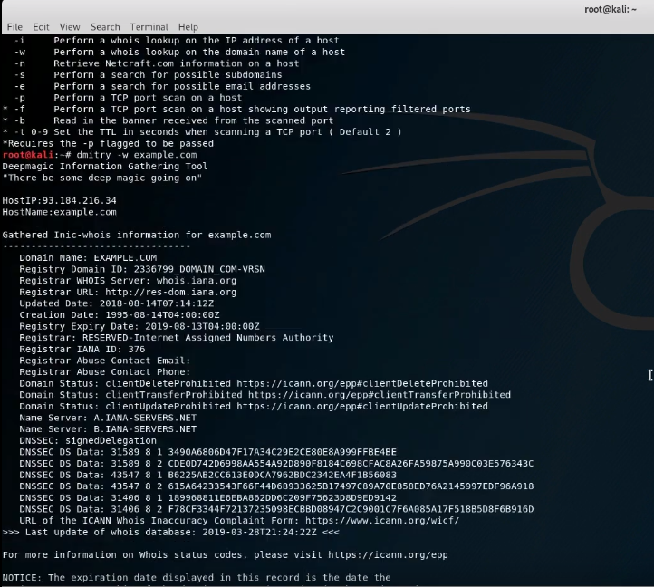

1.4 Information gathering for social engineering attacks:

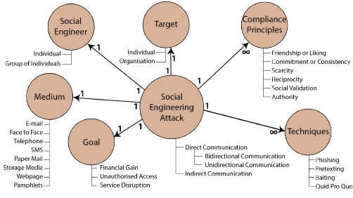

Step 1 :

* Open the kali linux
* Open the terminal
* Enter the command setoolkit

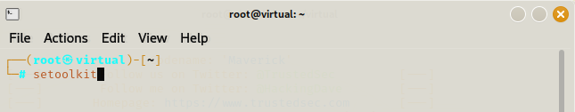

Step 2:

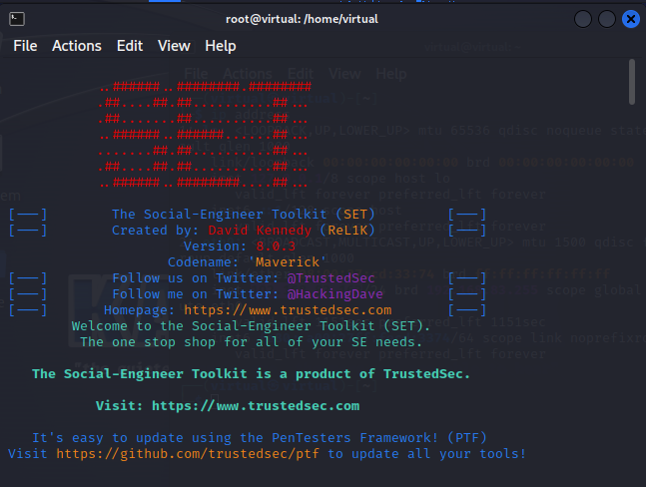



* Select from the menu of social engineering attack.

Step 3:

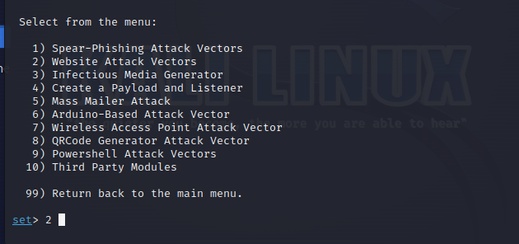

* Select from the memu in which you want to perform

Step 4:

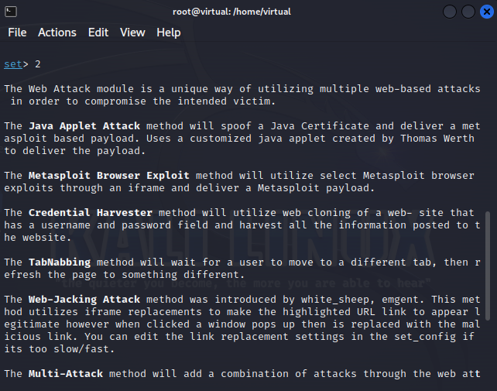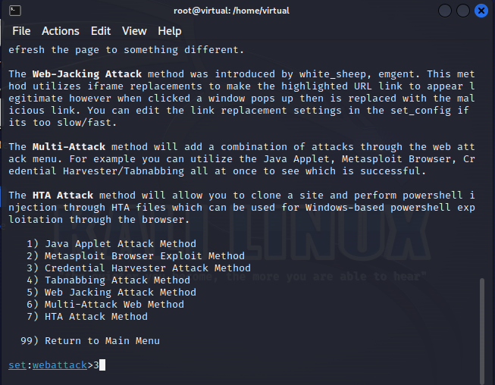

* Select from the memu in which you want to perform

Step 5:

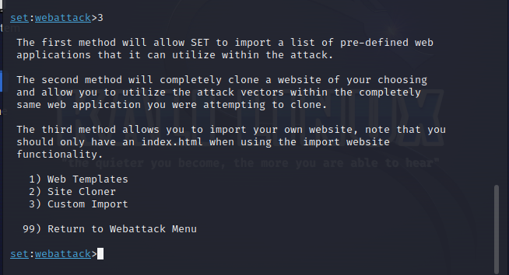

* Select from the memu in which you want to perform

•  Information gathering for physical security assessments:

## What Is a Physical Security Assessment?

A physical security assessment is a comprehensive audit of your organization’s physical security measures protecting your facilities, personnel, and assets. The assessment process evaluates your security systems and procedures, relative to the threats and risks you face, and recommends ways to [improve physical security in the workplace](https://www.alertmedia.com/podcast/improving-physical-security-in-the-workplace/). While security should be an organization-wide focus and cyberthreats are more important to address than ever, they’re outside the scope of a physical security assessment.

Unlike more limited evaluations—such as testing fire alarms or making sure cameras are working—a physical security audit is a 360-degree review. It covers everything from your building and security systems to plans and procedures to potential threats from your surrounding environment.

Some organizations have the expertise and resources to perform physical security assessments in-house, but many companies turn to security consultants who specialize in them. When possible, it’s best to both leverage your team’s knowledge and engage a specialist—an extra set of eyes can provide fresh perspectives and catch details that might otherwise slip through the cracks.

## Why Are Physical Security Risk Assessments Important?

At its core, security should prevent negative outcomes, be they injuries, loss of life, property damage, or theft. A physical security audit reduces the likelihood of these outcomes by identifying potential risks.

However, improved security through risk assessment isn’t merely preventative—it provides benefits in a few other ways too.

### Improve business resilience and risk management

Every company will face challenges, whether it’s severe weather, accidents, or acts of malice. An in-depth physical security assessment can identify vulnerabilities for all of these scenarios and curative measures you can take for [risk mitigation](https://www.alertmedia.com/blog/risk-mitigation/). By implementing these safeguards, you can improve your [business resilience](https://www.alertmedia.com/blog/business-resilience/) and give your team the resources they need to deal with problems as they occur.

### Foster a positive safety culture

One of the key tenets of a [positive safety culture](https://www.alertmedia.com/blog/building-safety-culture/) is providing an environment where employees believe you have their security and welfare in mind. By performing physical security assessments, addressing vulnerabilities, and communicating updated procedures, you’re displaying organizational commitment to safety and security.

### Maintain regulatory compliance

In some industries, physical security and vulnerability assessments aren’t just a good idea; they’re a requirement. There are a variety of regulations covering physical security—many of them related to companies storing sensitive information—but these are four of the most common:

* [International Organization for Standardization (ISO) 27001](https://www.iso.org/standard/27001), which is a comprehensive set of guidelines for information security
* [The Health Insurance Portability and Accountability Act (HIPAA)](https://www.hhs.gov/hipaa/index.html), a U.S. law that governs how companies can handle health data
* [Payment Card Industry Data Security Standards (PCI-DSS)](https://www.pcisecuritystandards.org/), a security standard for any business that processes credit card transactions
* [Occupational Safety and Health Administration (OSHA) Hazard Identification and Assessment](https://www.osha.gov/safety-management/hazard-Identification), which provides industry-specific guidelines for security and hazard inspections

Identify your business’ most critical threats with this fill-in-the-blank template.

GET THE TEMPLATE

## Five Steps to a Thorough Physical Security Risk Assessment

The details and specifics will vary based on organizational and environmental factors, but the following five areas should be part of any physical security assessment checklist.

### 1. Inspect your facilities and sites

The first step is to evaluate the spaces and structures you’re securing. The goal is to understand both strengths and weaknesses, keeping in mind that physical security management isn’t just about preventing crime—it’s also about protecting against accidents, natural disasters, and other potential threats.

Here are some of the most common items to consider during a building security assessment:

* Is there appropriate lighting in both internal and external spaces?
* What are the sightlines like around entrances and exits to the facility?
* Have electrical systems and wiring shown any signs of degradation?
* Are there any plumbing issues that could lead to building damage or accident hazards?
* Do all of the doors, windows, gates, and other points of entry close and lock properly?
* Are areas with critical assets physically partitioned from spaces with general access?
* Is safety equipment, like fire extinguishers and smoke detectors, all in good working order?

### 2. Audit your physical security systems

Next, you need to assess your security systems and how they cover the physical spaces your company has. Target-hardening techniques include:

* Access control systems, whether it’s biometric, card-based, or old-fashioned keys
* Personnel, including supervisors, staff in your [security operations center (SOC)](https://www.alertmedia.com/blog/security-operations-center/), and security guards throughout your facility
* Surveillance cameras, monitors, and the storage devices that contain recordings
* Alarm systems and supporting systems that notify local law enforcement in the event of a problem

Since all of these systems work hand-in-hand, the questions you’ll ask will usually involve interactions between systems and/or resources. For example:

* Are there any times of day when security personnel aren’t monitoring the CCTVs covering sensitive areas?
* Are there alarms that should go off if someone bypasses access control systems, and will they notify the right people?
* Does your surveillance camera network have any critical blind spots that would allow unauthorized access?
* Can your SOC seamlessly leverage all of your security systems to both prevent and respond to security issues as they arise?

### 3. Review your operating procedures

Even the most robust security systems are useless if your organization’s procedures don’t align with your security goals. For example, a company that manufactures toxic chemicals would establish the security goal of keeping the general public away, for everyone’s safety. But if they leave external doors unsecured and don’t partition off sensitive areas, their procedures wouldn’t reflect that goal.

In this phase of the process, you’ll be assessing the effectiveness of your policies and security plans. While the focus of this exercise is physical security, the rise of [converged security](https://www.alertmedia.com/blog/converged-security/) means you’ll also be touching on cybersecurity issues.

In this step, you’ll evaluate everything from security policies to emergency plans, such as:

* What kind of overnight/off-hours security presence do you maintain on-site?
* How should employees report suspicious activity or a potential security issue?
* Which essential personnel have elevated access to the facility in the event of an emergency, and how is that controlled?
* Do you have [evacuation plans](https://www.alertmedia.com/blog/emergency-evacuation-plan/) available and emergency exits clearly marked?
* Have you trained all of your employees on using your [two-way communication platform](https://www.alertmedia.com/products/emergency-mass-notification/)?
* Do you have [emergency response plans](https://www.alertmedia.com/blog/emergency-response-plan/) for events like robberies or active shooter situations?
* Are all of your employees aware of your plans and procedures and able to access them easily?

### 4. Identify physical security risks

Every business faces different risks, based on a combination of both internal and external factors. For example, a bank in the heart of New York City houses extremely valuable assets in a dense, urban environment, with a high volume of people visiting every day.

Conversely, a vacuum repair shop in South Dakota will operate in a slower-paced environment, with fewer visitors and less valuable inventory. That’s not to say the vacuum repair shop necessarily faces fewer risks, but they’re very different from the bank’s.

Specific risk factors will vary based on your company, but these are some core topics all businesses should consider:

* **Surroundings:** What are the crime rates in your area, and what types of crime are most prevalent?
* **Natural disasters:** Are you in a region that’s prone to specific disasters or severe weather like earthquakes, hurricanes, or snowstorms?
* **Workforce:** Does your company have high turnover and thus a repeated influx of new people in positions of responsibility?
* **Visitors or customers:** Are you in an industry that has a constant stream of unknown entities at your facility?
* **Inventory and assets:** Do you store or possess high-value items at your facility, and how portable are they? Securing small but valuable items like gold coins is very different from large objects like expensive printing presses or machinery.

### 5. Assess specific threats and vulnerabilities

Once you have a handle on the risks your company faces, you can assess which threats are the most realistic. The two most important factors to consider are the likelihood of a threat materializing and its potential impact on your business. For example, a meteor striking your office would be devastating, but the event is unlikely enough to more or less ignore.

In the course of assessing threats, you’ll be looking for vulnerabilities and ways to fix them with security measures. For example, a retail establishment in an urban environment would view theft as a key threat. The occasional stolen candy bar won’t put anyone out of business, but losses add up over time. With that in mind, they’d look at [retail loss-prevention](https://www.alertmedia.com/blog/retail-loss-prevention/) strategies in the context of their business to minimize theft, such as:

* Having a security guard at the entrance as a visible means of deterrence
* Constantly monitored surveillance cameras
* Keeping valuable merchandise in secured areas of the store
* Training staff on how to deal with shoplifters and whether they should engage them
* Lighting with motion sensors to deter loitering in the evening and overnight
* Rollup doors or external gates to provide an extra layer of security while the business is closed

## A Proactive Approach to Improving Physical Security

Security professionals face a constantly evolving threat landscape, and it can feel daunting to try to predict what’s coming next and meet your organization’s security needs. Between weather, worldwide pandemics, bad actors, and the vagaries of life, there are a wide array of factors outside your control.

However, what you do control is your company’s preparedness to meet the unknown. By taking a proactive approach to identifying realistic threats and determining how your physical security shapes up against them, you can anticipate problems before they happen. You might not be able to see every hazard lurking, but you’ll have confident procedures to activate and trained individuals ready to act on known and unknown threats.

1.5 Emerging trends and technologies in information gathering:

The IT industry is always active and on the go. Whatever your interests are, the virtual world has something for you. Here are the top emerging trends in information technology unfolding with their brief encapsulation.

### 1. Artificial Intelligence and Machine Learning

Artificial Intelligence (AI) and Machine Language (ML) have been unquestionably one of the latest advancements. Consequently, [its market](https://dataprot.net/statistics/ai-statistics/#:~:text=37%25%20of%20businesses%20and%20organizations,million%20new%20ones%20by%202025) will reach $267 billion by 2027. Today you can find AI and ML in every field, from finance and healthcare to manufacturing and retail. The robust AI and ML pair aims to improve, automate, and process time-sensitive data with minimal human interference requirements.

You can accelerate business processes, make informed decisions with an accurate perception of the purchasing behavior, gear the customer experience, and enable chatbots for communication. AI and ML allow you to extract value from piles of data, deliver business insights, automate tasks, ensure safety operations, and enhance system capabilities.

**Recommended Read:** [Mobile Apps Transformation- One Step Closer To AI and ML](https://www.yourteaminindia.com/blog/mobile-apps-transformation-one-step-closer-to-ai-and-ml)

### 2. Advanced Analytics

Advanced or predictive analytics generate a predictive model for specific applications, like marketing. It combines Artificial Intelligence and statistical techniques to anticipate outcomes. You can evaluate historical data, identify patterns, and observe trends to determine potential future events before they happen.

It can aid in optimizing processes and performance, reducing risk, increasing asset utilization, and procuring more revenue opportunities, among other features. You can use the model to analyze dynamic market conditions and make strategic decisions, thus improving overall performance.

### 3. Datafication

Small and large firms across all sectors depend on data. It is safe to say that data underpins modern life; hence, it is vital to secure it. Smartphones, AI devices, industrial machines, etc., use data to communicate with humans and enhance lifestyles. Today you can transmute some aspects of your life into devices and software via data.

Datafication means converting human chores into data-driven technology. It transforms labor-intensive and manual procedures into digital devices powered by data. You can use real-time information to change social behavior into quantified data and improve customer experience.

### 4. Robotic Process Automation

[Robotic Process Automation](https://www.signitysolutions.com/rpa-consulting-services) (RPA) has been slowly gaining ground over the past decade. It utilizes various applications and software to automate manual tasks. You can lower expenses by automating data collection, analysis, and customer service.

In addition to reducing costs, you can focus on critical tasks by using bots to handle repetitive operations. It leads to an efficient workflow and better performance. Almost [95% of firms](https://www2.deloitte.com/ro/en/pages/about-deloitte/articles/95-dintre-organizatiile-care-folosesc-solutii-de-tip-rpa-spun-ca-tehnologia-le-a-imbunatatit-productivitatea.html) using Robotic Process Automation (RPA) admit that it improved productivity.

**Learn More:**[An Ultimate Guide To RPA (Robotic Process Automation)](https://www.signitysolutions.com/blog/robotic-process-automation-guide)

### 5. Augmented and Virtual Reality

The virtual reality gaming industry and Augmented Reality revealed that humans are open to the idea of escaping the real world. Virtual Reality (VR) and Augmented Reality (AR) are modifying how you use screens and unlock the door to engaging and interactive experiences. Unsurprisingly, the [VR and AR market](https://www.statista.com/outlook/amo/ar-vr/worldwide) may accumulate revenue worth $31.12 billion with 28.8% user penetration this year.

VR and AR technologies create and augment a captivating virtual environment and real-world scene. Virtual Reality places you inside a computer-generated landscape using a headset. Meanwhile, Augmented Reality plucks digital elements and puts them in your surroundings via a smartphone or visor.

### 6. Quantum Computing

Traditional and legacy systems are often slow and fail to meet work standards. Leading IT trends claim quantum computing is the next generation of computers. The [Quantum computing market](https://www.g2.com/articles/it-statistics) will exceed $2.5 billion by 2029. The technology transmits and processes information per quantum mechanics.

Instead of conventional binary codes, quantum computing utilizes superposition-based qubits. It simplifies code processing and offers instant output. A binary system needs trillions of bits to calculate a 100-particle system; quantum computing only requires 100 qubits to do the same.

### 7. Low-Code Technology

Low code is a visual approach that presents a quicker and easier software development process. [Approximately 84% of organizations](https://kissflow.com/low-code/low-code-stats/#:~:text=84%25%20of%20enterprise%20businesses%20have,investment%20to%20accelerate%20digital%20transformation.) have implemented it to alleviate the stress of the IT team. Low code reduces hand-coding and features interactive tools to streamline app creation.

You can use in-built templates with drag and drop your preferred elements. It significantly improves the time-to-market and enhances customer satisfaction via simple navigation controls.

### 8. Natural Language Processing

Financial marketing is the number one Natural Language Processing (NLP) user. The technology obtains data from repositories, shares valuable insights into market sentiment, and informs about tender delays and closings.

NLP empowers computers to comprehend text and words the same way humans can. It assists in machine processes and equips devices to perform mundane tasks themselves. A few examples of NLP include spell check, ticket classification, and summarization.

### 9. CyberSecurity

The advent of computers and the internet formulated a new digital cyber sphere. A cyberattack occurs [every 39 seconds](https://dataprot.net/statistics/cyber-security-statistics/). The increase in attacks and threats only underscores the need for a viable solution. Moreover, the old saying, “prevention is better than cure,” fits well in the cyber world, where businesses lose [$188,400 on cybercrime recovery](https://dataprot.net/statistics/cyber-security-statistics/).

Cybersecurity is a must-have for all internet users. You would not want to leave your computer and virtual data open for hackers, yes? Firewalls, antivirus software, and other software gain momentum as developers equip the earlier versions with cutting-edge features.

### 10. Cloud Migration

Are you looking to improve your agility to develop better workload management? Cloud computing or migration is the key! [Around 80% of enterprises](https://www.cloudzero.com/blog/cloud-computing-statistics) leverage multiple public or private cloud services. It enables efficient compliance processes, business operations, and data analysis.

Cloud computing blends software, business models, platforms, and infrastructure. Thus, you can maximize seamless adaptability, increase time to value, and meet the current demands of your industry.

### 11. Blockchain

You are not alone if you think of Bitcoin the minute someone says blockchain! It is understandable, seeing how banking and financial institutions were the first to explore its potential and benefits. However, blockchain is not all about digital currency!

It is a distributed ledger technology that records and tracks transactions and assets in the corporate. Gartner forecasts blockchain technology will generate over [$3.1 trillion in business value](https://findstack.com/resources/blockchain-statistics/) by this decade. The decentralized model can manage credit risk and ensures immutable, safe, and private customer profiling. It promotes transparency and accountability in online transactions and asset ownership.

Say you are a part of the manufacturing sector. You can use blockchain technology to engineer a supply chain management system. The supply chain management platform will track goods, offer better visibility to business users, and record the processes.

### 12. Internet of Things

The IoT is a network of objects containing software, sensors, or other technical components. It minimizes human intervention and facilitates connection and data exchange between these devices or objects. The vast potential of IoT promises to add value to daily operations. Hence, companies planning to [invest about $15 trillion](https://dataprot.net/statistics/iot-statistics/#:~:text=In%202021%2C%20there%20were%20more,in%20economic%20value%20by%202025) in IoT by 2025 are no longer a shocker.

IoT allows you to achieve extensive functionality by furnishing a broader network. Artificial Intelligence, Machine Learning, information security, and data analytics back the technology. You can employ the technology to create software frameworks, craft applications, and release the final product.

### 13. 3D Printing

You may have already noticed the surging merge between the digital and physical worlds. 3D Printing is one of the processes contributing to the said theory. In fact, experts dub it the [stimulant for the next industrial revolution](https://hbr.org/2015/05/the-3-d-printing-revolution).

3D Printing enables you to formulate prototypes. It fuses thin layers of liquid or powdered plastic, cement, or metal to fabricate a physical structure from a digital design. The versatile technology feathers production and innovation, as various industries rely on it for end-use parts.

### 14. Edge Computing

Edge computing is probably one of the least acknowledged but the latest IT trend. Gartner predicts that [75% of companies](https://www.gartner.com/smarterwithgartner/what-edge-computing-means-for-infrastructure-and-operations-leaders) will use Edge to create and process enterprise-generated data by 2025. Edge computing comprises a computation near the data generators at the network edge. The paradigm processes data closer to where you generated it.

It results in faster processing and excellent action-led output in real-time. You can process data from remote locations using a device or a local server. Further, it reduces latency and stores data in a centralized location when processing it in data centers.

### 15. Genomics

Modern technologies influence every aspect of businesses today. Of course, healthcare and medicine are no exception. Digital tools, like X-rays, have been around for a while and allow you to diagnose defects in bones and joints. But can you leverage technology to analyze your DNA and beat off diseases? Absolutely!

Genomics technology studies your DNA and genes’ makeup and maps them. It also simplifies the diagnosis process and allows doctors and skilled professionals to detect possible health issues before they become critical. It involves technical analysis, design, and diagnostics, besides theoretical research.

### 2. *Vulnerability Identification*

2.1 Identify and name each vulnerability:

Vulnerability identification is a crucial aspect of cybersecurity, and it involves discovering weaknesses or flaws in systems, networks, applications, or processes that could be exploited by attackers. Here are some common vulnerabilities along with their names:

1. SQL Injection (SQLi): SQL injection is a type of cybersecurity vulnerability that occurs when an attacker inserts malicious SQL code into an input field, leading to unauthorized access to a database. This can allow attackers to manipulate or steal sensitive data, modify or delete records, or even gain administrative privileges.

2. Cross-Site Scripting (XSS): Cross-Site Scripting is a vulnerability that enables attackers to inject malicious scripts into web applications. When users visit the affected web page, the malicious script executes in their browsers, potentially stealing sensitive information, hijacking sessions, or delivering other harmful payloads.

3. Cross-Site Request Forgery (CSRF): CSRF is a type of attack where an attacker tricks a user's web browser into making unintended requests to a vulnerable website. If the user is authenticated on that site, the attacker can perform actions on the user's behalf, such as changing settings or initiating financial transactions.

4. Remote Code Execution (RCE): RCE vulnerabilities allow attackers to execute arbitrary code on a target system, often gaining full control over the system. These vulnerabilities can lead to catastrophic consequences if exploited, such as taking over servers or devices.

5. Server-Side Request Forgery (SSRF): SSRF is a type of vulnerability that allows attackers to make requests from the server to internal or external resources, potentially exposing sensitive data or systems to unauthorized access.

6. XML External Entity (XXE) Injection: XXE injection is a vulnerability that exploits XML parsers' capabilities to include external entities, which can lead to the disclosure of sensitive information, server-side request forgery, or denial of service attacks.

7. File Inclusion Vulnerabilities: File inclusion vulnerabilities allow attackers to include and execute malicious files on a web server. Examples include Local File Inclusion (LFI) and Remote File Inclusion (RFI).

8. Insecure Direct Object References (IDOR): IDOR vulnerabilities occur when an application does not properly validate or authorize user access to objects or resources, allowing attackers to access unauthorized data or perform unauthorized actions.

9. Buffer Overflow: Buffer overflow vulnerabilities arise when an application does not properly validate the length of data input, allowing attackers to overwrite adjacent memory and execute arbitrary code or crash the application.

10. Missing Security Updates/Patches: Failing to apply security updates and patches for operating systems, applications, or firmware can leave systems exposed to known vulnerabilities that attackers can exploit.

**2.1.1 IDENTIFICATION OF VULNERABILITIES USING NMAP TECHNIQUE :**

Step 1:

* Open the kali Linux terminal
* Enter the sudo su to enter into professional terminal after sudo su -enter -password .
* Enter

“ git clone https:// github.com/vulnerscom/nmap-vulners.git ” .

* Enter “ cd ” .



Step 2:

* Enter the command “ nmap -sV IP address ” for open ports scanning.

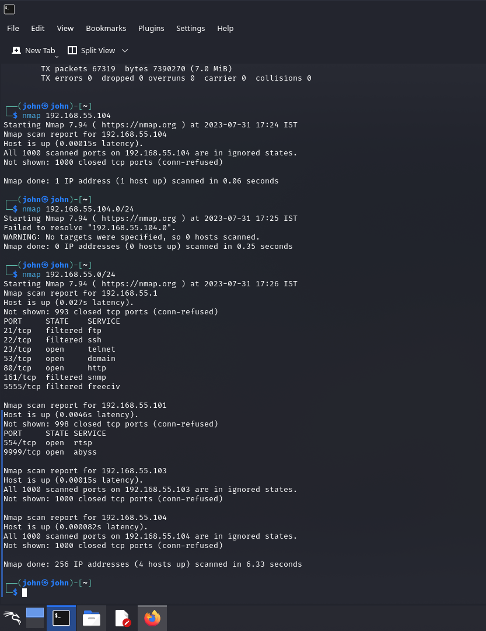

Step :3

* Enter the command “ nmap –script vuln IP address ”

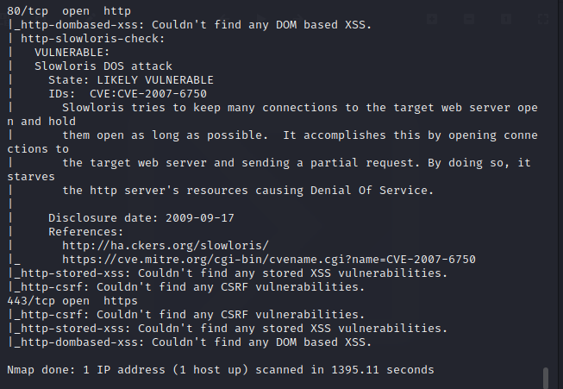

* IDs: CVE: CVE-2007-6750

Step 4:

* Search for vulnerability of CVE-2007-6750



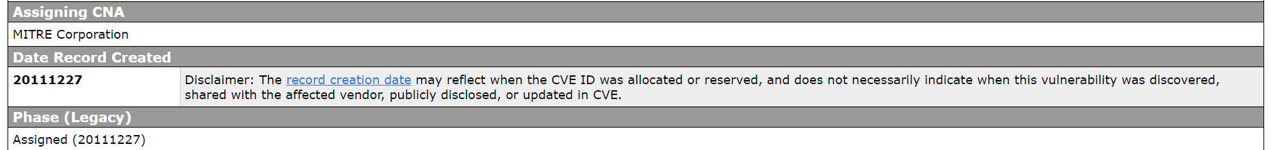

2.2 Assign a Common Weakness Enumeration (CWE) code to each vulnerability :

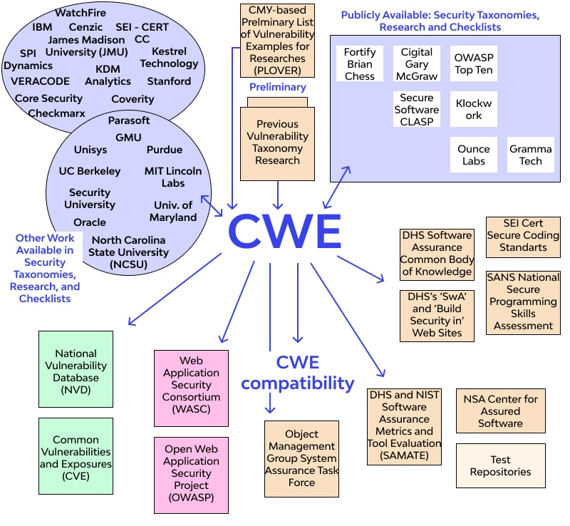

 2.3 Provide corresponding Open Web Application Security Project  (OWASP) category and description for each vulnerability :

## OWASP Top 10 Vulnerabilities

So, what are [the top 10 risks according to OWASP](https://info.veracode.com/owasp-top-10-infographic-resource.html)? We break down each item, its risk level, how to test for them, and how to resolve each.

### 1. Injection

Injection occurs when an attacker exploits insecure code to insert (or inject) their own code into a program. Because the program is unable to determine code inserted in this way from its own code, attackers are able to use injection attacks to access secure areas and confidential information as though they are trusted users. Examples of injection include [SQL injections](https://www.veracode.com/security/sql-injection), command injections, CRLF injections, and LDAP injections.

Application security testing can reveal injection flaws and suggest remediation techniques such as stripping special characters from user input or writing parameterized SQL queries.

### 2. Broken Authentication

Incorrectly implemented authentication and session management calls can be a huge security risk. If attackers notice these vulnerabilities, they may be able to easily assume legitimate users' identities.

Multifactor authentication is one way to mitigate broken authentication. Implement DAST and SCA scans to detect and remove issues with implementation errors before code is deployed.

### 3. Sensitive Data Exposure

APIs, which allow developers to connect their application to third-party services like Google Maps, are great time-savers. However, some APIs rely on insecure data transmission methods, which attackers can exploit to gain access to usernames, passwords, and other sensitive information.

Data encryption, tokenization, proper key management, and disabling response caching can all help reduce the risk of sensitive data exposure.

### 4. XML External Entities

This risk occurs when attackers are able to upload or include hostile XML content due to insecure code, integrations, or dependencies. An SCA scan can find risks in third-party components with known vulnerabilities and will warn you about them. Disabling XML external entity processing also reduces the likelihood of an XML entity attack.

### 5. Broken Access Control

If authentication and access restriction are not properly implemented, it's easy for attackers to take whatever they want. With broken access control flaws, unauthenticated or unauthorized users may have access to sensitive files and systems, or even user privilege settings.

Configuration errors and insecure access control practices are hard to detect as automated processes cannot always test for them. Penetration testing can detect missing authentication, but other methods must be used to determine configuration problems. Weak access controls and issues with credentials management are preventable with secure coding practices, as well as preventative measures like locking down administrative accounts and controls and using multi-factor authentication.

### 6. Security Misconfiguration

Just like misconfigured access controls, more general security configuration errors are huge risks that give attackers quick, easy access to sensitive data and site areas.

[Dynamic testing](https://www.veracode.com/products/dynamic-analysis-dast) can help you discover misconfigured security in your application.

### 7. Cross-Site Scripting

With cross-site scripting, attackers take advantage of APIs and DOM manipulation to retrieve data from or send commands to your application. Cross-site scripting widens the attack surface for threat actors, enabling them to hijack user accounts, access browser histories, spread Trojans and worms, control browsers remotely, and more.

[Training developers in best practices](https://www.veracode.com/products/security-labs) such as data encoding and input validation reduces the likelihood of this risk. Sanitize your data by validating that it’s the content you expect for that particular field, and by encoding it for the “endpoint” as an extra layer of protection.

### 8. Insecure Deserialization

Deserialization, or retrieving data and objects that have been written to disks or otherwise saved, can be used to remotely execute code in your application or as a door to further attacks. The format that an object is serialized into is either structured or binary text through common serialization systems like JSON and XML. This flaw occurs when an attacker uses untrusted data to manipulate an application, initiate a denial of service (DoS) attack, or execute unpredictable code to change the behavior of the application.

Although deserialization is difficult to exploit, penetration testing or the use of application security tools can reduce the risk further. Additionally, do not accept serialized objects from untrusted sources and do not use methods that only allow primitive data types.

### 9. Using Components with Known Vulnerabilities

No matter how secure your own code is, attackers can exploit APIs, dependencies and other third-party components if they are not themselves secure.

A static analysis accompanied by a [software composition analysis](https://www.veracode.com/products/software-composition-analysis) can locate and help neutralize insecure components in your application. Veracode’s [static code analysis tools](https://www.veracode.com/security/static-analysis-tool) can help developers find such insecure components in their code before they publish an application.

### 10. Insufficient Logging and Monitoring

Failing to log errors or attacks and poor monitoring practices can introduce a human element to security risks. Threat actors count on a lack of monitoring and slower remediation times so that they can carry out their attacks before you have time to notice or react.

To prevent issues with insufficient logging and monitoring, make sure that all login failures, access control failures, and server-side input validation failures are logged with context so that you can identify suspicious activity. [Penetration testing](https://www.veracode.com/security/penetration-testing) is a great way to find areas of your application with insufficient logging too. Establishing effective monitoring practices is also essential.

2.4 Understanding and defining vulnerabilities:

Vulnerabilities, in the context of cybersecurity and software development, refer to weaknesses or flaws in systems, networks, applications, or processes that could be exploited by attackers to compromise the security of the system or cause unintended behavior. These weaknesses create opportunities for unauthorized access, data breaches, denial of service, or other forms of cyberattacks.

To understand vulnerabilities better, let's break down the concept:

1. Types of Vulnerabilities: There are various types of vulnerabilities, each representing a specific weakness in a system. Some common types include:
   * Software Vulnerabilities: These arise due to coding errors or design flaws in software applications. Examples include SQL injection, cross-site scripting (XSS), and buffer overflow.
   * Configuration Vulnerabilities: These occur when systems are not configured securely, leaving them open to attacks. For instance, default passwords or unnecessary open ports could be exploited.
   * Hardware Vulnerabilities: These vulnerabilities are related to flaws in hardware components. Hardware vulnerabilities can be exploited to gain unauthorized access or control over a device.
   * Human-Induced Vulnerabilities: People can inadvertently introduce vulnerabilities, such as through social engineering or by sharing sensitive information online.
2. Impact of Vulnerabilities: The impact of vulnerabilities can vary depending on the nature of the weakness and the attacker's intent. Common consequences of exploiting vulnerabilities include:
   * Unauthorized access: Attackers can gain access to sensitive data, user accounts, or control over systems.
   * Data breaches: Sensitive information can be stolen, leading to privacy violations and identity theft.
   * Denial of Service (DoS): Attackers can overload systems or networks, causing them to become unresponsive.
   * Escalation of privileges: Attackers can gain higher levels of access than they are supposed to have.
   * Code execution: Attackers can run malicious code on vulnerable systems,
   * leading to further compromise.
3. Identifying and Mitigating Vulnerabilities: The process of identifying and addressing vulnerabilities is a critical part of cybersecurity. Techniques to handle vulnerabilities include:
   * Vulnerability Scanning and Assessments: Regularly scanning systems and applications for vulnerabilities to identify potential weaknesses.
   * Patch Management: Promptly applying security patches and updates to fix known vulnerabilities.
   * Secure Coding Practices: Following coding best practices and using secure development methodologies to reduce the likelihood of introducing vulnerabilities.
   * Security Testing: Conducting penetration testing and security assessments to simulate real-world attacks and identify vulnerabilities.
   * Security Awareness Training: Educating employees and users about security best practices to reduce human-induced vulnerabilities.
   * Implementing Security Controls: Deploying security measures, such as firewalls, intrusion detection systems, and encryption, to prevent and mitigate potential attacks.

2.5 Assigning CWE codes to each vulnerability:

1. SQL Injection (SQLi): CWE-89

2. Cross-Site Scripting (XSS): CWE-79

3. Cross-Site Request Forgery (CSRF): CWE-352

4. Remote Code Execution (RCE): CWE-94

5.Server-Side Request Forgery (SSRF): CWE-918

6. XML External Entity (XXE) Injection: CWE-611

7. Local File Inclusion (LFI)\*\*: CWE-22

8. Remote File Inclusion (RFI): CWE-98

9. Insecure Direct Object References (IDOR): CWE-639

10. Buffer Overflow: CWE-120

11. Missing Security Updates/Patches: CWE-937

12. Insecure Authentication: CWE-287

13. Insecure Communication: CWE-319

14. Insecure Deserialization: CWE-502

15. Weak Passwords: CWE-521

16. Information Disclosure: CWE-200

17. Security Misconfigurations: CWE-815

18. Zero-Day Vulnerabilities: CWE-937 (Similar to missing security updates, as zero-day vulnerabilities are unknown and unpatched.

2.6 Providing OWASP category and description for each vulnerability:

1. \*\*SQL Injection (SQLi)\*\* - OWASP Category: Injection

- Description: SQL injection allows attackers to manipulate SQL queries executed by the application, potentially gaining unauthorized access to the database, reading sensitive information, modifying data, or executing administrative actions.

2. \*\*Cross-Site Scripting (XSS)\*\* - OWASP Category: Cross-Site Scripting (XSS)

- Description: XSS enables attackers to inject malicious scripts into web pages viewed by other users, leading to unauthorized access to user sessions, stealing cookies, or hijacking user interactions.

3. \*\*Cross-Site Request Forgery (CSRF)\*\* - OWASP Category: Cross-Site Request Forgery (CSRF)

- Description: CSRF attacks trick authenticated users into performing unintended actions on a vulnerable website, potentially leading to unauthorized operations on the user's behalf.

4. \*\*Remote Code Execution (RCE)\*\* - OWASP Category: Injection

- Description: RCE vulnerabilities allow attackers to execute arbitrary code on a target system, potentially gaining complete control over the system.

5. \*\*Server-Side Request Forgery (SSRF)\*\* - OWASP Category: Server-Side Request Forgery (SSRF)

- Description: SSRF vulnerabilities allow attackers to make unintended requests from the server, accessing unauthorized resources or disclosing sensitive data.

6. \*\*XML External Entity (XXE) Injection\* - OWASP Category: XML External Entities (XXE)

- Description: XXE vulnerabilities exploit XML parsers that process external entities, leading to unauthorized access to files, SSRF attacks, or denial of service.

7. \*\*Local File Inclusion (LFI)\*\*- OWASP Category: Path Traversal

- Description: LFI vulnerabilities allow attackers to include and execute local files on a web server, potentially leading to unauthorized access or code execution.

8. \*\*Remote File Inclusion (RFI)\*\* - OWASP Category: Path Traversal

- Description: RFI vulnerabilities allow attackers to include and execute remote files on a web server, potentially leading to unauthorized access or code execution.

9. Insecure Direct Object References (IDOR)

- OWASP Category: Insecure Direct Object References (IDOR)

- Description: IDOR vulnerabilities occur when an application exposes internal references, allowing attackers to access unauthorized resources or perform unauthorized actions.

10. Buffer Overflow - OWASP Category: Buffer Overflow

- Description: Buffer overflow vulnerabilities occur when an application writes data beyond the bounds of a buffer, potentially leading to arbitrary code execution or application crashes.

11. Missing Security Updates/Patches

- OWASP Category: Insufficient Software Updating

- Description: Failure to apply security updates and patches can leave systems vulnerable to known exploits and attacks.

12. Insecure Authentication

- OWASP Category: Authentication

- Description: Insecure authentication mechanisms, such as weak passwords or improper validation, can lead to unauthorized access to user accounts or sensitive data.

13. Insecure Communication

- OWASP Category: Cryptographic Failures - Description: Transmitting sensitive data over unencrypted channels can lead to data interception and theft.

14. Insecure Deserialization

- OWASP Category: Insecure Deserialization

- Description: Insecure deserialization allows attackers to exploit flaws in the deserialization process, potentially leading to code execution or other attacks.

15. Weak Passwords

- OWASP Category: Credentials Management - Description: The use of easily guessable or weak passwords can make user accounts vulnerable to brute force attacks.

16. Information Disclosure

- OWASP Category: Information Leakage

- Description: Information disclosure vulnerabilities unintentionally reveal sensitive information, such as error messages or debug data, to unauthorized users.

17. Security Misconfigurations

- OWASP Category: Security Misconfiguration

- Description: Poorly configured systems, applications, or servers expose unnecessary services or default credentials to attackers

### 3.Business Impact Assessment

A business impact assessment (BIA) is a process that identifies and assesses the effects that accidents, emergencies, disasters, and other unplanned, negative events could have on a business. It is also known as business impact analysis. The BIA predicts how a business will be affected by everything from a hurricane to a labor strike

3.1 Conduct a thorough analysis of the potential

business impact of each vulnerability :

## Threat, Vulnerability and Risk

More and more organizational leaders and Boards of Directors are asking the question, “is my security adequate?”  To that question, one can only respond with another question, which is “adequate for what?”  In our personal lives, if we want to know what is wrong with us, we will visit a doctor to be checked out or, as a minimum, have periodic evaluations of our general health.  What would your reaction be, if without any testing or diagnosis whatsoever, your doctor suddenly informed you that you needed a serious operation?  You would question why a conclusion is being drawn without an investigation and rightfully so!  Similar philosophy should be applied to your security program.  Significant changes to your security should not be implemented without the proper diagnosis called the risk assessment.  As you read this article, can you produce the proof or articulate to your leadership or Board of Directors that you have identified and addressed the most likely security risks associated with your critical assets?  This article will provide key definitions and demonstrate that the terms, “threat,” “vulnerability” and “risk” are not interchangeable.  I will discuss various methodologies to help you get the desired outcome of a security analysis.  While there are many ways to assess security, none are more effective than the comprehensive risk assessment that considers all three elements of risk as shown below.

**Risk = Threat + Consequence + Vulnerability**

Risk in this formula can be broken down to consider the likelihood of threat occurrence, the effectiveness of your existing security program, and the consequences of an unwanted criminal or terrorist event occurring.  Here are some basic definitions to clarify the parts of the formula and the variations in outcome which occur if any portion of the three-part analysis is omitted.

**Threat** – a criminal or terrorist event which can have negative consequences on a critical asset.  Critical assets can typically be put into several categories:

* People
* Property or Monetary
* Continuity of Operations
* Intellectual Property
* Reputation

Threats to people might take the form of workplace violence, with or without a weapon, from a variety of sources which are further defined elsewhere (view our page on [workplace violence prevention](https://www.securingpeople.com/workplace-violence-prevention-intervention/)) and will not be described in detail in this article.

**Vulnerability** – The next part of the risk assessment addresses vulnerability or “effectiveness of security”.  Vulnerability is synonymous with susceptibility or weakness in an organization’s ability to prevent an attack against a critical asset.

**Consequence**– Consequence can be viewed as the degree of negative impact an incident would have if it were to occur.  The table below shows an illustration of how one might develop a consequence model for an organizational security risk assessment.  While the people safety consequence dimension is easy to define, the other consequence dimensions are very personal to each organization and will have to be determined at the onset of a security risk assessment.

A consequence model for injury to personnel is shown below from most to least significant:

* Fatality
* Hospitalization
* Lost time injury
* First Aid
* No injury

Organizations will need to develop their own models for other dimensions of consequence such as financial as $100,000 to one company may be catastrophic to one organization while for another it may be less than an insurance deductible.

When planning a risk assessment, the easiest way to define threats for your organizational audience is to translate threats against critical assets in the form of a defined scenario.  That scenario then becomes the risk that you will assess in your risk assessment.  For example, “a receptionist is injured by an irate customer in the lobby.”

**Determining the Threat Level** – Using the risk formula, you will start by determining the likelihood of the receptionist being attacked by an irate customer.  This will involve studying previous security incident history and considering the nature of the business.  For instance, if the organization is a law firm that deals with foreclosures, one might conclude that outsiders impacted by losing a home may come to the office angry, thus increasing the likelihood of a physical attack.

**Vulnerability or determining the effectiveness of security**– Properly identifying vulnerability requires a baseline knowledge set about what constitutes an effective physical security posture against common threats.  This suggests that a certified security professional might be engaged when conducting a security risk assessment for better results, but it is not essential.  Whenever an organization takes a systematic look at threats, vulnerability and consequences, it is better than guessing or being unduly influenced by a vendor promoting products.

So, what happens when you begin to do something less than considering all three elements of the risk formula?  What follows is a description of risk management methodologies with a graphic to show what is considered versus what is omitted from consideration.

**Threat Assessment**– If you want to simply study the criminals or terrorists who may have an interest and create security problems for your organization, you might start with a threat assessment.  This will encompass a study of only the first part of the formula as shown below.

**~~Risk~~ = Threat + ~~Consequence + Vulnerability~~**

**Threat Assessment Focus**

**Vulnerability Assessment**– Many counter-terrorism initiatives mandated by the US government are called vulnerability assessments.  A vulnerability assessment will consider only two of the three elements of the risk formula.  The threat level will be assumed to be at the highest level, and the organization will be forced to simply improve their security effectiveness by reducing vulnerability and find ways to reduce consequences which might include enhancing emergency response or developing business continuity plans.  A vulnerability assessment typically results in excessive spending on security as the actual threat level and probability of incident occurrence is omitted from consideration.

**~~Risk~~ = ~~Threat~~ + Consequence + Vulnerability**

**Vulnerability Assessment Focus**

**Business Impact Analysis**–A business impact analysis is another common methodology used in some organizations to identify the most critical of assets and build resiliency around those assets, often in the form of business continuity plans.  Business Impact analyses may not consider threats or vulnerability and again result in spending that might not otherwise be indicated if the full spectrum of risk is considered.

**~~Risk~~ = ~~Threat~~ + Consequence + ~~Vulnerability~~**

**Business Impact Analysis Focus**

**Security Audit**–A security audit is probably the easiest methodology to execute as it is simply a verification that all security measures which are supposed to be in place are in fact in place and functioning correctly.  The security audit will focus on the effectiveness of security or determine that vulnerability is being properly mitigated.  The security audit certainly has its place in the analysis landscape, but it is not an assessment of risk and is unlikely to identify unknown vulnerability.

**~~Risk~~ = ~~Threat~~ + ~~Consequence~~ + Vulnerability (or effectiveness of security)**

**Security Audit Focus**

In closing, there are several different security assessment methodologies.  Hopefully, it is clear from this article that the terms “threat,” “vulnerability” and “risk” are not synonymous and cannot be used interchangeably.  The most effective means of determining security adequacy is to consider all three elements of risk – threat, vulnerability and consequence.  Risk assessments should be the methodology of choice if you are seeking to determine your security adequacy and avoid the potential pitfalls associated with failing to meet the expectations of the OSHA General Duty Clause or a successful claim against you under premises liability tort law

3.2Understand the potential consequences of each vulnerability on the business:

Understanding the potential consequences of each vulnerability on the business is an important part of the Business Impact Analysis (BIA) process. The BIA identifies and assesses the effects that accidents, emergencies, disasters, and other unplanned, negative events could have on a business.



3.3 Conducting a business impact assessment :

The steps to conducting business analysis impact can differ from company to company depending on their requirements and team. However, the general steps of how to conduct a business impact analysis are as follows:

1. Getting approval from senior [management](https://www.knowledgehut.com/blog/others/what-is-management).
2. Selecting experienced staff to perform a BIA.
3. Preparing a detailed business impact assessment template and the plan.
4. Gathering information from interviews, documentation, and questionnaires.
5. Evaluating the gathered data.
6. Performing an analysis so that the technologies needed could be discussed.
7. Preparing a report or a detailed BIA template.
8. Showing the results to senior management.
9. Define strategies for recovery after examining the results.
10. Using these results to develop a sample business impact analysis plan and then working with the team and seniors to make it a final plan.

To learn more about conducting effective business analysis, one can choose KnowledgeHut which offers some of the best business analyst courses. The courses cover everything from the basics of impact analysis to advanced aspects for assessing the potential ramifications of proposed changes under the guidance of project [management](https://www.knowledgehut.com/blog/others/what-is-management) professionals. [KnowledgeHut’s best Business Analyst courses](https://www.knowledgehut.com/business-management-courses" \t "_blank) are interactive and engaging, offering students the opportunity to learn through real-world examples.

## Phases of Business Analysis Impact

The business impact analysis process involves 4 phases. They are:

### 1. Define the Objectives and Scope

The first phase is to define the goals, major objectives, and scope of the business impact analysis. The business's goals should be clear. Once approval has been obtained, businesses should gather trained people to perform a BIA together. These individuals should understand the organization's business processes well and be familiar with risk assessment methods.

### 2. Collect Data and Information

After initiating the business analysis phase, the analyst will gather information. This is done through a variety of means, including a BIA questionnaire template, interviews, and documentation review. The goal is to collect data that is relevant to the analysis and that can help to answer questions about the problem or opportunity at hand. Once this information has been gathered, it can be used to generate insights and recommendations.

**The collected information should include:**

* The process name
* What the process entails in detail
* Inputs and outputs
* All business impact analysis tools and resources to be used in the process
* Users involved in the process
* Timing
* Financial and operational affect
* Regulatory and legal impacts
* Historical data

### 3. Review the Information

The third phase of business impact analysis is information review. This is the process of documenting and reviewing the collected data to prioritize a list of business functions or processes, identify human and technology resources needed, and establish a recovery timeframe. This phase can be automated or done manually, depending on what is easiest, reliable, and, most importantly, practical.

This phase is important in crisis management and contingency planning because it helps company leaders make decisions about allocating resources and managing operations during and after a disruptive event. Information review might seem a basic part of the business impact analysis process, but it is an essential step in making sure that your company is prepared for any eventuality.

### 4. Making a Detailed Report

One of the most important business impact analysis steps is making a detailed report. This report comprehensively documents the findings of the previous phases and offers recommendations for recovery in the event of a disruptive incident.

Here is a business impact analysis report example explained in detail:

The report begins with an executive summary, which provides an overview of the objectives, the scope of the analysis, and a summary of the findings. This is followed by a section on methodology, which outlines the data-gathering and evaluation methods used.

The next section presents a detailed finding on the most crucial processes, the disruption impact, acceptable duration, acceptable loss level, recovery cost, etc. The report concludes with a section on supporting documents and recovery suggestions.

The final phase of business analysis impact is showing the Business Impact Analysis (BIA) report to seniors. The report should be shown to seniors to get their input on the findings and recommendations. The analysts can choose from any business impact analysis template excel available online to present the report.

After the BIA report has been reviewed and approved by seniors, it can be used to develop a plan of action in the event of a disruption. The goal of this phase is to ensure that seniors are aware of the risks and impacts associated with disruptions and that they understand the role they play in mitigating those risks.

## Effects of Not Performing a Business Analysis Impact

Not conducting a business impact analysis can result in significant negative impacts on an organization. These include the following:

1. Lack of clarity on which business processes are critical and need to be safeguarded.

2. Inadequate protection of key assets and resources.

3. Poorly designed continuity plans that do not take into account all risks.

4. Increased exposure to financial, reputational, and legal risks in the event of a disruption.

5. Difficulty obtaining insurance coverage or adequate compensation from insurers in the event of a loss.

6. Poor decision-making during a crisis is due to a lack of information about the potential impacts of various actions.

Conducting a business impact analysis risk assessment is essential for any organization that wishes to protect itself from the potentially devastating effects of disruptions. By identifying critical business processes and assets, organizations can ensure that their continuity plans are comprehensive and effective and that they are taking all necessary steps to mitigate risks.

## Common Challenges with Business Analysis Impact

In business analysis, the impact of a change should be measured to ensure that it is worth implementing. However, this can be difficult to do accurately. There are several common challenges that analysts face when trying to assess the impact of a change:

1. First, predicting how users will react to a change can be difficult. They may not use the new features as intended or find workarounds that negate the impact of the change.

2. Second, it can be hard to identify all the stakeholders affected by a change. Some stakeholders may have hidden agendas that make them resistant to change, while others may be unaware of the potential impacts.

3. Third, analysts must deal with uncertainty when assessing impact. Changes often have complex ripple effects that are difficult to predict.

4. Fourth, analysts must balance conflicting demands when assessing impact. For example, a change that benefits one group of users may have negative consequences for another group.

5. Fifth, analysts need to take into account both tangible and intangible factors when assessing impact. For example, a change may improve efficiency but make users feel less engaged with their work.

.

3.4 Understanding potential consequences of vulnerabilities:

Vulnerabilities can have various impacts such as an attacker exploiting a vulnerability could assume greater privileges on a compromised system, allowing them to potentially destroy data or take control of computers for malicious purposes. Vulnerabilities in popular software can place many customers using the software at a heightened risk of a data breach, or supply chain attack. Vulnerabilities can affect the confidentiality, integrity or availability of your systems, data, people and more. Zero-day vulnerabilities can lead to financial losses, loss of customer trust, cyber warfare, and other complications. [Vulnerabilities can result in a negative impact to confidentiality, integrity, or availability](https://www.intel.com/content/www/us/en/security-center/impact-of-vulnerability.html).

One example of a vulnerability that led to a data breach is weak credentials. The vast majority of data breaches are caused by stolen or weak credentials. [If malicious criminals have your username and password combination, they have an open door into your network1](https://www.kaspersky.com/resource-center/definitions/data-breach).



3.5 Assessing the risk to the business:

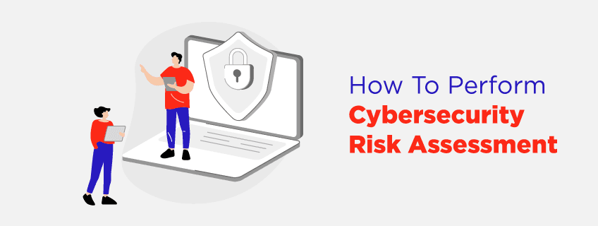

A cybersecurity risk assessment evaluates an organization's ability to protect its information and information systems from cyber threats. It identifies, assesses, and prioritizes cyber risks to information and systems that are in use by a company. An organization's cybersecurity risk assessment identifies, prioritizes, and communicates its cybersecurity risks to stakeholders, which allows them to make informed decisions about how to deploy resources. In cybersecurity risk [management](https://www.knowledgehut.com/blog/others/what-is-management), threats are prioritized according to their potential impact. Organizations utilize cybersecurity risk management to identify, analyze, evaluate, and address the most critical threats as soon as possible.

As a result, threats can be identified, analyzed, evaluated, and dealt with based on their potential impact.  You can all do this when you have good [cyber security training](https://www.knowledgehut.com/cyber-security-courses). Information and information systems risks should be identified, assessed, and prioritized regardless of the approach taken by the organization.

## Who Should Perform a Cyber Risk Assessment?

A dedicated team within the organization should handle an organization's risk assessment. An assessment must include IT, staff with an understanding of your network and digital infrastructure, executives who understand how information flows, and any proprietary knowledge within your organization. In small businesses, there are likely not to be enough people in-house to perform a thorough assessment, and a third party will be required. In addition to monitoring cybersecurity scores, preventing breaches, and sending security questionnaires, organizations are also using cybersecurity software to reduce third-party risk.

### Cyber Security Audit Checklist

Data security and network environments have become increasingly complex and diverse in recent years. To ensure that a security system not only works properly for your organization, but is also safe and does not pose a security threat to your company and your data or the data of your customers, there are hundreds of pieces to it. They all need to be examined individually and collectively.

## Security Risk Assessment Model

Almost all companies do not even know the basics of cybersecurity. They don't know what they don't know about it. In addition to identifying security gaps at all levels, risk assessments also enable the detection and removal of high-level malware. The top security controls and prioritizing security risks also prevent unnecessary spending.

### 1. Identification

The basics of cybersecurity are simply unknown to many companies. Their knowledge of security gaps ranges from physical security to malware detection and removal. Risk assessments allow them to identify security gaps at all levels. By focusing on top security controls and prioritizing security risks, they also prevent unnecessary spending.

### 2. Assessment

The costs of the assessment cannot be compared to those of a breach that happens later. The HIPAA risk assessment chart demonstrates how companies can prioritize their security spending to minimize long-term costs. Many executives would not consider air conditioner maintenance a cyber security risk. Companies that act faster can be more cost-effective.

### 3. Mitigation

The effectiveness of a cyber security risk assessment report sample depends on their actionable recommendations for remediation activities. Assessment reports also need to explain how to secure systems by filling security gaps. Reports should also identify issues that seem problematic at first glance but that is so unlikely that they don't need to be addressed.

### 4. Prevention

Business is vulnerable to cybersecurity threats due to poor security practices among employees, and it can be patched via cybersecurity threat assessment. It becomes necessary to implement cyber security vulnerability assessment. Risk assessments help companies identify areas where employees should be trained to minimize future risks.

## Risk Assessment Components and Formula

It is important to conduct a thorough risk assessment before making significant changes to your security. While assessing security can be done in a variety of ways, none of them are as effective as a comprehensive risk assessment, which considers all three elements of risk.

**Risk = Threat + Consequence + Vulnerability**

An effective security program, the likelihood of a threat, and the consequences of an unwanted criminal or terrorist event should all be considered when calculating risk in this formula. Here are some definitions to clarify how the formula works and what happens when any part of it is omitted.

### 1. Threat

An event that can adversely affect a critical asset through a criminal or terrorist act. There are many categories of critical assets, including people, property, monetary, continuity of operation, intellectual property, and reputation. People can be threatened by violence at work, with or without weapons.

### 2. Determining the Threat Level

As part of the risk formula, you will analyze the history of security incidents and the nature of the business to determine the likelihood that an irate customer will attack the receptionist. The probability of physical attacks may increase if, for instance, the organization is a law firm dealing with foreclosures. The outsiders may become angry at the office when they lose a home.

### 3. Cyber Vulnerability Assessment

A vulnerability can be defined as a weakness in a company's ability to protect vital assets against an attack. In a risk assessment, vulnerability is synonymous with susceptibility.

### 4. Vulnerability or determining the effectiveness of security

When identifying a vulnerability, a basic understanding of what constitutes an effective physical security posture against common threats is necessary. In order to get the best results from a security risk assessment, it might be useful to engage a certified security professional, but it is not necessary. In order to avoid guesswork or unduly influence by vendors who are promoting products, organizations should take a systematic look at threats, vulnerabilities, and consequences.

### 5. Consequences

In terms of consequences, they can be viewed as the degree to which an incident will negatively impact. The table below provides an example of how an organization might develop a consequence model to assess security risks. Despite the fact that the people safety consequence dimension is easily defined, the other consequence dimensions will need to be determined at the beginning of the security risk assessment because they are very personal to each organization.

According to a consequence model for personnel injuries, fatalities, hospitalizations, lost time injuries, first aid, and no injuries are in order from most to least significant. A company's financial impact will require it to develop its model. For one company, $100,000 may be catastrophic to another, while for another, it may not be more than an insurance deductible.

A threat assessment can be defined easily by translating threats against critical assets into a defined scenario for your organizational audience. You will assess the risk based on that scenario in your risk assessment. For example, “an angry customer in the lobby hurts a receptionist.”

**Threat Assessments:**

If you want to simply determine whether criminals or terrorists may be interested in causing security problems at your organization, you could start with a threat assessment. This will focus primarily on the first part of the formula, as shown below.

**Risk = Threat + Consequence + Vulnerability**

### 6. Vulnerability Assessment

The US government mandates a number of counter-terrorism initiatives that are referred to as vulnerability assessments. Only two of the three elements of the risk formula will be considered in a vulnerability assessment. Considering that the threat level has reached the highest level, the organization will be forced to improve its security's effectiveness by reducing vulnerability and finding ways to reduce consequences, for example, by developing business continuity plans or enhancing emergency response procedures. In vulnerability assessments, incidents and threat levels are ignored, resulting in excessive security spending.

**Risk = Threat + Consequence + Vulnerability**

### 7. Business Impact Analysis

Another common methodology used in some organizations is business impact analysis, which involves identifying the most critical assets and building resilience around them, often in the form of business continuity plans. The full spectrum of risks might not be considered in Business Impact analyses, resulting in spending that would not otherwise be indicated.

**Risk = Threat + Consequence + Vulnerability**

### 8. Security Audits

As far as security audits are concerned, they are the easiest methodology to implement since they are simply a way of verifying that all security measures that are supposed to be in place are in place and working properly. Security audits will examine whether security measures are effective or if vulnerabilities are properly mitigated. Security audits have their place in analysis landscapes, but they are not risk assessments or likely to identify unknown vulnerabilities.

**Risk = Threat + Consequence + Vulnerability**

The security assessment methodology can be classified into several different types. Using the terms threat, vulnerability, and risk interchangeably or synonymously is impossible. Considering all three risk elements – threat, vulnerability, and consequence – is the most effective way to determine whether a security system is adequate. A risk assessment is the best approach if you are looking to determine whether your security measures are adequate and to avoid potential pitfalls such as failing to comply with the OSHA General Duty Clause or being sued for premises liability.

## How to Perform a Cybersecurity Risk Assessment [Step-by-Step]

### Step 1: Determine Information Value

As part of a risk assessment, deciding what is included in the assessment is important. Generally, it is not feasible to evaluate the entire organization, so it is usually more practical to examine a single business unit, location or particular aspects of the business, such as payment processing or a web application. To understand which assets and processes are most important, identify risks, assess impacts, and define risk tolerance levels, all stakeholders whose activities are within the scope of the assessment need their full support.

### Step 2: Identify and Prioritize Assets

It is impossible to protect what you don't know, so the next step is to identify all physical and logical assets included in the risk assessment and create an inventory of them. The importance of identifying assets does not just lie in identifying those that are the organization's crown jewels and are likely to be the most targeted by attackers. In addition to identifying assets that attackers would like to control, such as Active Directory servers, picture archives, and communications systems, to expand an attack, attackers could also use these assets as pivot points.

### Step 3: Identify Cyber Threats

It is time to determine whether the risk scenarios can happen and what impact they would have on the organization. Cyber security assessment and [management](https://www.knowledgehut.com/blog/others/what-is-management) should focus on the discoverability, exploitability and reproducibility of threats and vulnerabilities rather than historical occurrences to determine risk likelihood -- the probability that a threat can exploit a given vulnerability. A cybersecurity threat has a dynamic nature, meaning its likelihood does not necessarily correlate with previous occurrences as floods or earthquakes do.

### Step 4: Identify Vulnerabilities

The following cyber security risk assessment matrix can classify each risk scenario. For a cyber security risk assessment example, let's assume that  a SQL injection attack might be classified as "Likely" or "Highly Likely" if the likelihood of the attack is "Likely" or "Highly Likely."

The organization should prioritize treatment for any scenario that exceeds its agreed-upon risk tolerance level.

### Step 5: Analyze Controls and Implement New Controls

Risk Identification in cyber security and cyber security evaluation minimize or eliminate the risk of vulnerability or threat. Technology can be used to implement controls, such as hardware and software, encryption, intrusion detection, two-factor authentication, automatic updates, continuous data leak detection, or nontechnical means, such as security policies and physical mechanisms. Preventative controls work to prevent attacks by encrypting, using antivirus programs, or monitoring continuous security.

### Step 6: Calculate the Likelihood and Impact of Various Scenarios on a Per-Year Basis

Following a thorough understanding of the value of information, threats, vulnerabilities and controls, the next step is to identify how likely these cyber risks are to occur and the impact they will have. You can use these inputs to determine how much to spend to mitigate each of your identified cyber risks, not just whether you might encounter one of these events at some point but also how likely it is to succeed.

### Step 7: Prioritize Risks Based on the Cost of Prevention Vs. Information Value

Consider the risk level as a basis for determining actions that senior management or other responsible individuals should take to mitigate the risk. The following guidelines can help:

1. The high - quick development of corrective measures
2. Medium - In a reasonable period of time, the correct measures are developed
3. Low - Consider accepting or mitigating the risk when the risk is low

### Step 8: Document Results from Risk Assessment Reports

In order to ensure that management is always aware of its cybersecurity risks, it is essential to document all identified risk scenarios in a risk register and store them in a cybersecurity risk assessment report sample. The items in the plan should be Risk scenario, Identification date, Existing security controls, Current risk level, and Treatment plan -- the activities and timelines to reduce the risk to an acceptable level.

### 4.Vulnerability Path and Parameter Identification

### 4,1Methods for identifying vulnerability paths and

### parameters

Identifying vulnerability paths and parameters is a crucial part of cybersecurity risk assessment and penetration testing. Here are some common methods and techniques used to identify vulnerability paths and parameters:

1. \*\*Vulnerability Scanning:\*\* Vulnerability scanning tools like Nessus, OpenVAS, or Qualys can automatically scan networks, systems, and applications to identify known vulnerabilities and misconfigurations. These tools often use a database of known vulnerabilities to match against the target system's configuration and versions.

2. \*\*Manual Code Review:\*\* For applications and software, manual code reviews by skilled security professionals can help identify potential vulnerabilities in the codebase. Common security vulnerabilities like SQL injection, cross-site scripting (XSS), and others can be identified through this process.

3. \*\*Penetration Testing:\*\* Conducting penetration tests involves actively simulating attacks on the target system to identify vulnerabilities. Ethical hackers or security experts use various tools and techniques to exploit potential weaknesses and gain unauthorized access to systems.

4. \*\*Fuzz Testing:\*\* Fuzz testing (or fuzzing) is an automated testing technique that involves providing random, invalid, or unexpected data as inputs to a system to identify potential vulnerabilities, especially in software applications.

5. \*\*Threat Modeling:\*\* Threat modeling is a systematic approach to identify potential threats and vulnerabilities in a system. It helps in understanding how an attacker might approach the system and which paths they could exploit.

6. \*\*Web Application Security Assessment:\*\* Specialized security tools and manual testing techniques can be used to assess the security of web applications. Tools like Burp Suite and OWASP ZAP can help identify potential weaknesses in web applications.

7. \*\*Network Mapping and Enumeration:\*\* Network scanning and enumeration techniques can help identify potential attack surfaces, services, and systems that might be vulnerable.

8. \*\*Social Engineering Assessments:\*\* Social engineering assessments test the human element of security by attempting to manipulate employees or users to reveal sensitive information or grant unauthorized access.

9. \*\*Log Analysis:\*\* Analyzing system logs and event logs can reveal unusual or suspicious activities that may indicate potential vulnerabilities or ongoing attacks.

10. \*\*Security Information and Event Management (SIEM) Tools:\*\* SIEM tools can centralize and analyze logs from various sources, helping to identify patterns or potential threats.

1. \*\*Zero-Day Vulnerability Research:\*\* Some organizations or security researchers focus on discovering and reporting previously unknown vulnerabilities, known as zero-day vulnerabilities.

4.2 Types of vulnerability paths and parameters

Vulnerability paths and parameters can vary widely based on the type of system or application being assessed. Here are some common types of vulnerability paths and parameters found in various environments:

1. \*\*Web Application Vulnerabilities:\*\*

- SQL Injection (SQLi): Attacker can manipulate SQL queries to gain unauthorized access to the database.

- Cross-Site Scripting (XSS): Allows attackers to inject malicious scripts into web pages viewed by other users.

- Cross-Site Request Forgery (CSRF): Forces users to perform unwanted actions in their authenticated web application.

- File Inclusion Vulnerabilities: Allows an attacker to include files from the server that should not be publicly accessible.

- Command Injection: Allows an attacker to execute arbitrary commands on the server.

2. \*\*Network Vulnerabilities:\*\*

- Open Ports and Services: Misconfigured or unnecessary open ports and services may expose attack surfaces.

- Weak Network Protocols: Insecure protocols like Telnet or outdated encryption protocols like SSLv2 may be exploitable.

- Man-in-the-Middle (MitM) Attacks: Attackers intercept and manipulate network communications.

- Denial of Service (DoS) Attacks: Overloading or crashing systems or services to disrupt availability.

3. \*\*Operating System Vulnerabilities:\*\*

- Unpatched Software: Failure to apply security updates leaves systems vulnerable to known exploits.

- Default Credentials: Systems or applications with unchanged default login credentials.

- Privilege Escalation: Unauthorized users gain higher levels of access to a system or application.

4. \*\*Mobile Application Vulnerabilities:\*\*

- Insecure Data Storage: Sensitive data stored in an insecure manner, allowing unauthorized access.

- Insecure Communication: Data transmitted over insecure channels, making it susceptible to interception.

- Code Tampering: Attackers modify the application code to bypass security measures or gain unauthorized access.

5. \*\*IoT Device Vulnerabilities:\*\*

- Weak Authentication: IoT devices using default or weak credentials.

- Lack of Encryption: Data transmitted or stored without encryption, leading to potential data breaches.

- Vulnerable Firmware: Unpatched or outdated firmware with known vulnerabilities.

6. \*\*Social Engineering Vulnerabilities:\*\*

- Phishing Attacks: Manipulating individuals into revealing sensitive information or credentials.

- Pretexting: Creating a fabricated scenario to trick individuals into disclosing information.

- Tailgating: Gaining unauthorized physical access to a restricted area by following an authorized person.

7. \*\*Cloud Security Vulnerabilities:\*\*

- Insecure APIs: Inadequately secured interfaces can lead to unauthorized access.

- Misconfiguration: Improperly configured cloud services and permissions.

- Shared Tenancy Risks: Risks associated with sharing cloud resources with other tenants.

8. \*\*Physical Security Vulnerabilities:\*\*

- Unauthorized Access: Physical access to sensitive areas without proper authentication.

- Lack of Surveillance: Insufficient monitoring or surveillance measures.

These are just some examples of vulnerability paths and parameters. It's important to consider the specific context and technology stack of the system or application being assessed to identify its unique vulnerabilities. Regular security assessments and risk analysis are crucial to maintaining a robust security posture.

4.3 Common tools and techniques for identifying vulnerability paths and parameters

Identifying vulnerability paths and parameters is an essential part of the vulnerability assessment and penetration testing process. There are several common tools and techniques that security professionals use to perform this task effectively. Here are some of them:

1. \*\*Manual Inspection and Code Review:\*\* One of the fundamental techniques is to manually inspect the application's source code and configurations. This helps identify potential security issues, such as SQL injection, cross-site scripting (XSS), insecure authentication mechanisms, and more.

2. \*\*Web Vulnerability Scanners:\*\* Automated web vulnerability scanners like Burp Suite, OWASP ZAP, and Acunetix are commonly used to scan web applications for known vulnerabilities. These tools can detect issues like SQL injection, XSS, CSRF, and other security weaknesses.

3. \*\*Network Vulnerability Scanners:\*\* Tools like Nessus, OpenVAS, and Rapid7 can be used to scan networks and systems for known vulnerabilities and misconfigurations.

4. \*\*Fuzzing:\*\* Fuzz testing or fuzzing involves sending random or malformed data as inputs to the application to identify unexpected behavior or crashes that may indicate vulnerabilities.

5. \*\*Penetration Testing:\*\* Penetration testing involves actively trying to exploit vulnerabilities to assess the impact of potential attacks. Skilled ethical hackers simulate real-world attacks to identify and demonstrate potential vulnerabilities.

6. \*\*Security Headers Analysis:\*\* Checking the presence and proper configuration of security headers (e.g., Content Security Policy, X-XSS-Protection, X-Content-Type-Options) to ensure secure communication and mitigate specific attack vectors.

7. \*\*OWASP Top 10:\*\* The OWASP Top 10 list provides a valuable reference for identifying common web application security risks. Security professionals use this list as a guide to check for these vulnerabilities.

8. \*\*Vulnerability Databases:\*\* Regularly checking known vulnerability databases like the National Vulnerability Database (NVD) and the Common Vulnerabilities and Exposures (CVE) database can help identify vulnerabilities associated with specific software versions.

9. \*\*Burp Collaborator:\*\* Burp Collaborator is a tool used to detect out-of-band vulnerabilities like blind SQL injection and server-side request forgery (SSRF).

10. \*\*Google Hacking Database (GHDB):\*\* Using specially crafted search queries, the GHDB can help find sensitive information that may have been unintentionally exposed on the internet.

11. \*\*Protocol Analyzers:\*\* Network protocol analyzers like Wireshark can be used to capture and analyze network traffic to identify potential security weaknesses.

12. \*\*Manual Testing with Various Inputs:\*\* Security professionals often perform manual testing with different inputs (e.g., valid, invalid, and boundary values) to uncover vulnerabilities and weaknesses in an application's input validation.

4.4 Best practices for vulnerability path and parameter identification

When it comes to vulnerability path and parameter identification in cybersecurity, following best practices ensures that the process is effective, efficient, and conducted in a secure and responsible manner. Here are some best practices to consider:

1. \*\*Authorization and Consent:\*\* Always obtain proper authorization from the system owners or stakeholders before conducting any vulnerability assessment or penetration testing. Written consent is essential to avoid legal repercussions.

2. \*\*Scope Definition:\*\* Clearly define the scope of the assessment, including the systems, networks, and applications to be tested. This prevents unintentional testing on unauthorized systems.

3. \*\*Stay Updated with Vulnerabilities:\*\* Keep abreast of the latest security vulnerabilities, attack vectors, and exploits by subscribing to security mailing lists, following CVE databases, and staying engaged with the cybersecurity community.

4. \*\*Utilize Best-of-Breed Tools:\*\* Choose reputable and widely used tools for vulnerability scanning and penetration testing. These tools are more likely to have comprehensive coverage and be regularly updated with the latest vulnerabilities.

5. \*\*Manual Testing and Code Review:\*\* Rely on both automated tools and manual inspection for thorough assessments. Automated tools can identify common vulnerabilities, but manual review is essential for finding unique or complex issues.

6. \*\*Verify Findings:\*\* Always verify identified vulnerabilities to ensure they are not false positives. False positive can waste time and resources and lead to incorrect conclusions.

7. \*\*Documentation:\*\* Maintain comprehensive documentation of the entire vulnerability assessment process, including methodologies, tools used, findings, and remediation recommendations.

8. \*\*Risk Prioritization:\*\* Prioritize identified vulnerabilities based on their severity and potential impact on the business. Focus on addressing high and critical-risk vulnerabilities first.

9. \*\*Secure Data Handling:\*\* Handle sensitive data with care during the assessment. Ensure that any collected data or findings are stored securely and shared only with authorized personnel.

10. \*\*Non-Destructive Testing:\*\* Conduct non-destructive testing whenever possible to avoid disrupting critical systems or causing unintended consequences.

11. \*\*Responsible Disclosure:\*\* If vulnerabilities are discovered in third-party software or applications, follow responsible disclosure practices to notify the vendors or developers privately and give them adequate time to address the issues before disclosing them publicly.

12. \*\*Continuous Monitoring:\*\* Cybersecurity is an ongoing process. Regularly conduct vulnerability assessments and penetration tests to identify new vulnerabilities that may arise due to changes in the environment or software updates.

13. \*\*Training and Skill Development:\*\* Ensure that security professionals conducting the assessments have the necessary skills and training to perform the tasks effectively and safely.

14. \*\*Post-Assessment Remediation:\*\* After the assessment, work collaboratively with the organization to address and remediate the identified vulnerabilities promptly.

4.5 Challenges and limitations of vulnerability path and parameter identification;

Cyber Security is becoming a severe issue for individuals, enterprises, and governments alike. In a world where everything is on the internet, from cute kitten videos and our travel diaries to our credit card information, ensuring that our data remains safe is one of the biggest challenges of Cyber Security**.** Cyber Security challenges come in many forms, such as ransomware, phishing attacks, malware attacks, and more. India ranks 11th globally in terms of local cyber-attacks and has witnessed 2,299,682 incidents in Q1 of 2020 already.

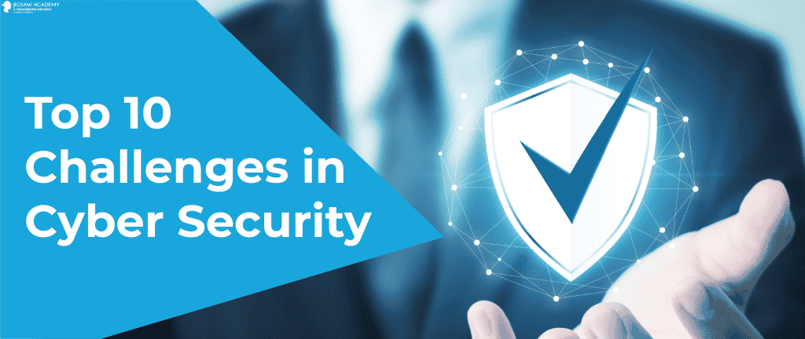

In this blog, we have compiled a list of the top 10 biggest challenges of Cyber Security in 2020 so that you can protect your personal and professional data against any potential threats.

Listing out some of the most common types of cyber-attacks:

1. [**Ransomware attacks**](https://u-next.com/blogs/cyber-security/challenges-of-cyber-security/#Ransomware-Attacks)
2. [**IoT attacks**](https://u-next.com/blogs/cyber-security/challenges-of-cyber-security/#IoT-Attacks)
3. [**Cloud attacks**](https://u-next.com/blogs/cyber-security/challenges-of-cyber-security/#Cloud-Attacks)
4. [**Phishing attacks**](https://u-next.com/blogs/cyber-security/challenges-of-cyber-security/#Phishing-Attacks)
5. [**Blockchain and cryptocurrency attacks**](https://u-next.com/blogs/cyber-security/challenges-of-cyber-security/#Blockchain-and-Cryptocurrency-Attacks)
6. [**Software vulnerabilities**](https://u-next.com/blogs/cyber-security/challenges-of-cyber-security/#Software-Vulnerabilities)
7. [**Machine learning and AI attacks**](https://u-next.com/blogs/cyber-security/challenges-of-cyber-security/#Machine-Learning-and-AI-Attacks)
8. [**BYOD policies**](https://u-next.com/blogs/cyber-security/challenges-of-cyber-security/#BYOD-Policies)
9. [**Insider attacks**](https://u-next.com/blogs/cyber-security/challenges-of-cyber-security/#Insider-Attacks)
10. [**Outdated hardware**](https://u-next.com/blogs/cyber-security/challenges-of-cyber-security/#Outdated-Hardware)

10 Biggest Challenges of Cyber Security in 2020

Let’s explore the list:

## 1. **Ransomware Attacks**

Ransomware attacks have become popular in the last few years and pose one of India’s most prominent Cyber Security challenges in 2020. According to the Cyber Security firm Sophos, about 82% of Indian organizations were hit by ransomware in the last six months. Ransomware attacks involve hacking into a user’s data and preventing them from accessing it until a ransom amount is paid. Ransomware attacks are critical for individual users but more so for businesses that can’t access the data for running their daily operations. However, with most ransomware attacks, the attackers don’t release the data even after the payment is made and instead try to extort more money.

## 2. **IoT Attacks**

According to IoT Analytics, there will be about 11.6 billion IoT devices by 2021. IoT devices are computing, digital, and mechanical devices that can autonomously transmit data over a network. Examples of IoT devices include desktops, laptops, mobile phones, smart security devices, etc. As the adoption of IoT devices is increasing at an unprecedented rate, so are the challenges of Cyber Security. Attacking IoT devices can result in the compromise of sensitive user data. Safeguarding IoT devices is one of the biggest challenges in Cyber Security, as gaining access to these devices can open the doors for other malicious attacks.

## 3. **Cloud Attacks**

Most of us today use cloud services for personal and professional needs. Also, hacking cloud platforms to steal user data is one of the challenges in Cyber Security for businesses. We are all aware of the infamous iCloud hack, which exposed private photos of celebrities. If such an attack is carried out on enterprise data, it could pose a massive threat to the organization and maybe even lead to its collapse.

## 4. **Phishing Attacks**



Phishing is a type of social engineering attack often used to steal user data, including login credentials and credit card numbers. Unlike ransomware attacks, the hacker, upon gaining access to confidential user data, doesn’t block it. Instead, they use it for their own advantages, such as online shopping and illegal money transfer. Phishing attacks are prevalent among hackers as they can exploit the user’s data until the user finds out about it. Phishing attacks remain one of the major challenges of Cyber Security in India, as the demographic here isn’t well-versed with handling confidential data.

## **5. Blockchain and Cryptocurrency Attacks**



While blockchain and cryptocurrency might not mean much to the average internet user, these technologies are a huge deal for businesses. Thus, attacks on these frameworks pose considerable challenges in Cyber Security for businesses as it can compromise customer data and business operations. These technologies have surpassed their infancy stage but have yet not reached an advanced secure stage. Thus, several attacks have been attacks, such as DDOS, Sybil, and Eclipse, to name a few. Organizations need to be aware of the security challenges that accompany these technologies and ensure that no gap is left open for intruders to invade and exploit.

## 6. **Software Vulnerabilities**

Even the most advanced software has some vulnerabilities that might pose significant challenges to Cyber Security in 2020, given that the adoption of digital devices now is more than ever before. Individuals and enterprises don’t usually update the software on these devices as they find it unnecessary. However, updating your device’s software with the latest version should be a top priority. These attacks are usually carried out on a large number of individuals, like the Windows zero-day attacks.

## 7. **Machine Learning and AI Attacks**

While Machine Learning and Artificial Intelligence technologies have proven highly beneficial for massive development in various sectors, it has its vulnerabilities as well. These technologies can be exploited by unlawful individuals to carry out cyberattacks and pose threats to businesses. These technologies can be used to identify high-value targets among a large dataset. Machine Learning and AI attacks are another big concern in India. A sophisticated attack might prove to be too difficult to handle due to the lack of Cyber Security expertise in our country.

## 8. **BYOD Policies**

Most organizations have a Bring-Your-Own-Device policy for their employees. Having such systems poses multiple challenges in Cyber Security. Firstly, if the device is running an outdated or pirated version of the software, it is already an excellent medium for hackers to access. Since the method is being used for personal and professional reasons, hackers can easily access confidential business data. Thus, organizations should let go of BYOD policies and provide secure devices to the employees, as such systems possess enormous challenges of Computer Security and network compromise.

## **9. Insider Attacks**

While most challenges of Cyber Security are external for businesses, there can be instances of an inside job. This can lead to huge financial and reputational losses for the business. These challenges of Computer Security can be negated by monitoring the data and the inbound and outbound network traffic. Installing firewall devices for routing data through a centralized server or limiting access to files based on job roles can help minimize the risk of insider attacks.

DETAILED INSTRUCTION FOR VULNERABILITY REPRODUCTION

* 1. Importance Of Providing Detailed Instructions

Providing detailed instructions is of utmost importance in various contexts, whether it's in written communication, task delegation, software development, or any other area where clear guidance is essential. Here are some reasons why detailed instructions are crucial:

1. Clarity: Detailed instructions leave no room for ambiguity. They provide clear and explicit guidance, ensuring that the recipient understands what is expected of them or how to perform a task correctly.

2. Reduced Errors: When instructions are detailed and comprehensive, it minimizes the chances of misunderstandings or misinterpretations, leading to fewer mistakes and errors.

3. Efficiency: Clear instructions help streamline processes. They enable individuals to complete tasks more efficiently, as they don't waste time seeking clarifications or making corrections.

4. Consistency: Detailed instructions promote consistency in performance. When everyone follows the same set of instructions, the outcomes are more uniform and predictable.

5. Accountability: In contexts where multiple people are involved in a project, detailed instructions establish accountability. It's easier to track progress and identify responsibilities when tasks are clearly defined.

6. Training and Onboarding: Detailed instructions are invaluable during training and onboarding processes. They help newcomers understand their roles, responsibilities, and how to perform tasks correctly.

7. Reproducibility: In scientific research and experimentation, detailed instructions are vital for reproducibility. Other researchers should be able to replicate the experiments and obtain the same results based on the provided instructions.

8. Customer Satisfaction: In customer support and service, detailed instructions help agents provide accurate and helpful information to customers, leading to higher satisfaction levels.

9. Risk Management: In safety-critical environments, detailed instructions play a crucial role in risk management. They ensure that tasks are performed safely and prevent accidents or incidents.

10. Legal and Compliance Requirements: In industries with strict regulations, detailed instructions help organizations comply with legal requirements and avoid potential penalties.

11. Accessibility and Inclusivity: Well-structured and detailed instructions are beneficial for people with diverse learning styles and abilities. They ensure that information is accessible to a broader audience.

12. Troubleshooting and Debugging: In software development and technical fields, detailed instructions aid in troubleshooting and debugging processes. It becomes easier to identify and fix issues when steps are clearly outlined.

In summary, detailed instructions enhance communication, productivity, and overall performance. They are vital for achieving consistent and accurate results, reducing errors, and ensuring that tasks are completed efficiently and responsibly.

* 1. Components Of A Well-Written Vulnerability Reproduction Instruction

A well-written vulnerability reproduction instruction is crucial for effectively communicating security issues to developers, engineers, or software vendors. It helps them understand the vulnerability, replicate it, and ultimately fix it. Here are the key components of a well-written vulnerability reproduction instruction:

1. Title and Summary: Begin with a clear and descriptive title that summarizes the vulnerability concisely. Follow it with a brief summary or introduction that outlines the nature and impact of the vulnerability.
2. Vulnerability Description: Provide a detailed description of the vulnerability, including how it was discovered, the affected component(s) or functionality, and the potential impact on the system's security or stability.
3. Affected Version(s): Clearly specify the version(s) of the software or system where the vulnerability exists. This information helps developers identify the scope of the issue and its relevance to different product versions.
4. Steps to Reproduce: This is the most critical part of the instruction. Clearly outline the step-by-step process to reproduce the vulnerability. Include all the necessary inputs, actions, and conditions required to trigger the vulnerability. Use numbered lists and provide specific details to make it easy for developers to follow the steps.
5. Required Environment: Specify the operating system, hardware, software dependencies, or any other environmental factors that might be relevant to reproduce the vulnerability. This ensures that the recipient can set up the required environment accurately.
6. Sample Code or Payload: If applicable, include sample code, payloads, or exploit scripts that demonstrate the vulnerability. However, exercise caution when sharing potentially harmful code, and consider using placeholders or obfuscation if necessary.
7. Screenshots or Videos: Visual aids, such as screenshots or videos, can be beneficial in illustrating the steps and the expected outcomes. They provide an additional layer of clarity, especially for graphical user interface (GUI) vulnerabilities.
8. Expected Behavior: Describe what the expected behavior should be at each step of the reproduction process. This helps the recipient confirm that they have accurately replicated the vulnerability.
9. Observed Behavior: Clearly state what actually happens when the vulnerability is triggered. Explain the deviation from the expected behavior, emphasizing the security implications.
10. Mitigation or Workaround (if applicable): If you have identified a temporary mitigation or workaround to mitigate the vulnerability's impact until a proper fix is available, include it in the instruction.
11. CVE Identifier (if assigned): If a Common Vulnerabilities and Exposures (CVE) identifier has been assigned to the vulnerability, include it in the instruction for easy tracking and reference.
12. Contact Information: Provide your contact information (e.g., email) so that the recipient can reach out for further clarification or communication.
13. Responsible Disclosure Statement: If you are reporting the vulnerability to the vendor or a responsible disclosure program, include a statement about responsible disclosure and your willingness to cooperate in the remediation process.

By including these components in your vulnerability reproduction instruction, you will enhance the chances of the vulnerability being understood, addressed, and ultimately resolved by the relevant parties. Remember to be clear, concise, and factual in your description, and always follow responsible disclosure practices to ensure the security of affected systems and users.

* 1. Steps For Reproducing Vulnerabilities

Reproducing vulnerabilities is an essential step in the security assessment process, as it helps verify the existence and impact of reported security issues. Here are the general steps to follow when reproducing vulnerabilities:

Step 1: Understand the Vulnerability Report

Carefully review the vulnerability report or disclosure provided by the reporter. Understand the nature of the vulnerability, the affected component, and the potential impact.

Step 2: Environment Setup

Set up an environment that closely resembles the one where the vulnerability was reported. This includes using the same software versions, configurations, and dependencies.

Step 3: Identify Affected Software Versions

Determine which versions of the software are affected by the vulnerability. Ensure you are using the correct version(s) during the reproduction process.

Steps 4: Recreate the Vulnerable Scenario

Follow the detailed instructions or steps provided in the vulnerability report to recreate the vulnerability. This may involve providing specific inputs, using crafted payloads, or following a specific sequence of actions.

Steps 5: Validate Results

Once you have followed the steps to reproduce the vulnerability, verify if the expected behavior mentioned in the report is observed. Confirm that the vulnerability manifests as described.

Steps 6: Document Findings

Record your findings, including the steps taken to reproduce the vulnerability, observed behavior, and any relevant data or payloads used. Include screenshots or videos if applicable to provide visual evidence.

Steps 7: Confirm Impact

Assess the impact of the vulnerability on the system's security and stability. Understand the potential consequences of the vulnerability being exploited.

Steps 8: Test Mitigations

If any temporary mitigations or workarounds were suggested in the report, test them to evaluate their effectiveness in reducing the vulnerability's impact.

Steps 9: Retest and Cross-Verify

To ensure accuracy, retest the steps multiple times and cross-verify with colleagues or other security experts if possible. This helps validate the findings and rule out false positives.

Steps 10: Ethical Considerations

If the vulnerability involves intrusive testing or exploitation attempts, ensure that you have appropriate authorization from the system owner or vendor. Always adhere to ethical hacking principles.

Steps 11: Prepare a Detailed Report

After successfully reproducing the vulnerability, prepare a detailed report documenting the steps taken, the impact of the vulnerability, and any recommended mitigations. Include all necessary information for the developers or vendors to understand and fix the issue.

Steps 12: Responsible Disclosure

If the vulnerability was discovered externally, follow responsible disclosure practices by notifying the affected vendor or organization about the findings. Allow them sufficient time to address the issue before disclosing it publicly.

The vulnerability reproduction is a critical step in the responsible disclosure process. It helps ensure the accuracy of reported vulnerabilities and assists developers in understanding and addressing the security issues effectively.

* 1. Best Practices for Writing Effective Vulnerability Reproduction Instructions

Writing effective vulnerability reproduction instructions is crucial to ensure that security issues are clearly understood and promptly addressed. Here are some best practices to follow when crafting these instructions:

* Be Clear and Concise: Use straightforward language and avoid unnecessary technical jargon. Clearly state the steps to reproduce the vulnerability without ambiguity.
* Provide Context: Start with a brief summary of the vulnerability and its potential impact. Include relevant background information about the affected software, version, and component.
* Step-by-Step Instructions: Outline the reproduction steps in a logical and sequential order. Use numbered lists or bullet points for easy readability.
* Specific Inputs and Conditions: Include precise details about the inputs, data, or conditions required to trigger the vulnerability. If certain requirements must be met, specify them clearly.
* Include Sample Payloads: If appropriate and safe, provide sample payloads or data inputs that demonstrate the vulnerability. Ensure these payloads are not malicious and are properly encoded or sanitized.
* Relevance of Environment: Specify the operating system, software versions, and relevant configurations used during the reproduction. Ensure the environment closely matches the one where the vulnerability was discovered.
* Expected vs. Observed Behavior: Clearly distinguish between the expected behavior and the observed behavior when the vulnerability is triggered. Explain any discrepancies.
* Visual Aids: Whenever possible, include screenshots, videos, or logs that visually demonstrate the vulnerability. Visual aids can enhance understanding and provide evidence.
* Mitigations and Workarounds: If you are aware of any temporary mitigations or workarounds, include them in the instructions to help reduce the vulnerability's impact.
* Risk Assessment: Provide an assessment of the potential impact of the vulnerability. Explain the risks it poses to the confidentiality, integrity, and availability of the system or data.
* Test for False Positives: Double-check your reproduction steps to avoid false positives, where a vulnerability may appear to exist but doesn't.
* Ethical Considerations: If the vulnerability involves intrusive testing or exploitation attempts, ensure you have proper authorization before proceeding.
* Contact Information: Include your contact information, such as email or a secure communication channel, so that the recipient can reach out for further clarifications.
* Responsible Disclosure Statement: If you are reporting the vulnerability to the vendor or a responsible disclosure program, include a statement about responsible disclosure and your commitment to cooperating in the remediation process.
* Review and Validate: Before sharing the instructions, review and validate them to ensure accuracy and completeness. If possible, have a colleague or another security expert review them as well.
* Clear Communication: When reporting the vulnerability, be polite, respectful, and avoid confrontational language. Remember that the goal is to improve security, not to criticize.

By following these best practices, you can significantly increase the chances of your vulnerability reproduction instructions being understood, acted upon promptly, and ultimately leading to the resolution of security issues. Responsible disclosure practices should always be followed, giving the affected party adequate time to address the vulnerability before it is publicly disclosed.

* 1. Tools And Techniques For Verifying Vulnerability Fixes

Verifying vulnerability fixes is a crucial step in the vulnerability management process to ensure that the reported security issues have been adequately addressed and that the fixes do not introduce new problems.

Here are some common tools and techniques used for verifying vulnerability fixes:

* Retesting: Perform a repeat of the steps used to reproduce the vulnerability before the fix was applied. Verify that the expected behavior is no longer observed, and the vulnerability is no longer exploitable.
* Code Review: If the vulnerability was fixed by modifying the application's source code, conduct a code review to assess the changes. Look for any potential coding mistakes or introduced security issues.
* Static Code Analysis: Utilize static code analysis tools to scan the fixed code for potential security flaws, code smells, or best practice violations.
* Dynamic Application Security Testing (DAST): Run DAST tools to scan the application after the fix has been implemented. These tools simulate attacks on the running application to identify vulnerabilities.
* Manual Penetration Testing: Perform manual penetration testing to actively test the application's security controls and ensure the vulnerability is not reintroduced.
* Automated Vulnerability Scanners: Use automated vulnerability scanners to check for any remaining vulnerabilities in the application or system after the fix has been applied.
* Verification with Proof of Concept (PoC): If a proof of concept was provided during the initial vulnerability report, use it to verify that the fix effectively mitigates the security issue.
* Verification with Public Exploit Code: Check if public exploit code for the vulnerability is available and test whether the fix successfully blocks the exploitation attempts.
* Review Vendor Releases and Patch Notes: If the vulnerability was reported to a software vendor, review the release notes and patch details provided by the vendor to understand the changes and verify the fix.
* Version Comparison: Compare the vulnerable version of the software with the patched version to identify the specific changes made to address the vulnerability.
* Third-Party Verification: Engage third-party security experts or independent auditors to verify the vulnerability fix independently.
* Fuzz Testing: Use fuzz testing techniques to generate a wide range of inputs and test the application for potential issues after the fix.
* Security Regression Testing: Conduct comprehensive security regression testing to ensure that the fix has not caused unintended side effects or broken any other functionalities.
* Configuration Review: Review the application or system's configuration settings to ensure that security settings have been correctly applied.
* Compliance and Policy Validation: Ensure that the vulnerability fix aligns with security policies, compliance requirements, and industry best practices.

It is crucial to document the verification process thoroughly, including the tools and techniques used, the results obtained, and any additional remediation steps taken. Properly verifying vulnerability fixes is essential to ensure the security of the application or system and provide confidence that the issues have been properly resolved.

* 1. Challenges And Limitations Of Vulnerability Reproduction Instruction

Vulnerability reproduction instructions is essential for clear communication between security researchers and developers.

However, there are several challenges and limitations that can hinder the accuracy and completeness of these instructions:

* Incomplete or Ambiguous Information: Insufficient or unclear details in the vulnerability report can lead to incomplete or ambiguous reproduction instructions. Missing information may result in difficulty for developers to accurately understand and fix the vulnerability.
* Lack of Context: Reproduction instructions might not always provide the necessary context about the affected components, system configurations, or user interactions, making it challenging to replicate the vulnerability accurately.
* Environment Variability: Differences in the testing environment between the security researcher and the developers can lead to variations in vulnerability reproduction. Factors such as operating systems, software versions, or network settings may affect the vulnerability's behavior.
* Complex Vulnerabilities: Some vulnerabilities may be intricate and involve multiple steps or conditions. Capturing all the necessary details to reproduce such complex vulnerabilities can be challenging.
* Timing and Transient Vulnerabilities: Certain vulnerabilities might be transient and only manifest under specific conditions or for a limited time. Reproducing such vulnerabilities may be difficult due to timing constraints.
* Privilege Requirements: Vulnerabilities that require specific user privileges or system access may be challenging to reproduce in controlled testing environments.
* External Dependencies: Vulnerabilities may rely on external services or data sources, making it difficult to reproduce the issue without access to those dependencies.
* Safety and Ethics: In some cases, reproducing vulnerabilities might involve potentially harmful or intrusive actions. Ethical considerations and safety concerns must be taken into account when crafting instructions.
* Human Error and Bias: The vulnerability reporter's assumptions, biases, or misunderstandings during the reproduction process could inadvertently lead to inaccuracies in the instructions.
* Limited Access to Source Code: Without access to the complete source code of the application, security researchers may struggle to understand certain vulnerabilities fully and provide accurate reproduction instructions.
* False Positives or Negatives: The reproduction instructions might lead to false positives (mistakenly identifying vulnerabilities) or false negatives (failing to reproduce actual vulnerabilities).
* Lack of Feedback Loop: A lack of effective communication between the security researcher and the developers might hinder the refinement of reproduction instructions, leading to delays in fixing vulnerabilities.

 6 COMPREHENSIVE AND DETAILED REPORTING

* 1. Importance Of Comprehensive And Detailed Reporting

Network vulnerability assessment is a systematic evaluation of a network's security posture to identify potential weaknesses and vulnerabilities that could be exploited by malicious actors. It involves a thorough examination of network devices, systems, applications, and configurations to ensure the network's integrity, confidentiality, and availability.

Comprehensive and detailed reporting is of utmost importance in various fields and contexts, especially in areas where accuracy, clarity, and understanding are critical.

Here are some key reasons why comprehensive and detailed reporting is essential:

* Clear Communication: Comprehensive and detailed reports facilitate clear communication of complex information. They ensure that all relevant details and context are provided, reducing the risk of miscommunication and misunderstandings.
* Accurate Understanding: Detailed reporting helps recipients grasp the full scope and nuances of the subject matter. It enables them to make informed decisions based on accurate and complete information.
* Informed Decision-Making: Decision-makers rely on comprehensive reports to evaluate options, assess risks, and devise effective strategies. Detailed information allows for well-informed choices.
* Problem-Solving and Troubleshooting: In technical fields, detailed reporting is vital for troubleshooting and problem-solving. Engineers and technicians can better identify issues and propose solutions with comprehensive information.
* Quality Assurance and Compliance: In regulated industries, comprehensive reporting is necessary to meet quality assurance and compliance standards. Detailed documentation ensures that processes and practices adhere to established guidelines.
* Learning and Knowledge Transfer: Detailed reports serve as valuable learning resources. They allow others to study, understand, and build upon past experiences, improving knowledge transfer within organizations and industries.
* Avoiding Misinterpretation: Comprehensive reporting reduces the likelihood of misinterpretation or misrepresentation of data or findings, fostering more accurate and reliable conclusions.
* Building Trust and Credibility: A well-documented and comprehensive report enhances the credibility of the author or organization. It demonstrates professionalism and a commitment to transparency.
* Legal and Investigative Matters: In legal or investigative contexts, detailed reports are essential for presenting evidence and documenting findings in a thorough and organized manner.
* Effective Collaboration: Detailed reporting facilitates effective collaboration among team members, stakeholders, and experts. Everyone is on the same page, leading to smoother coordination and progress.
* Continuous Improvement: Comprehensive reporting allows for better analysis and evaluation of processes and outcomes, leading to continuous improvement and optimization.
* Long-Term Record-Keeping: Detailed reports serve as a long-term record of activities, findings, and decisions, providing valuable historical context for future reference.
* Risk Management: In risk assessment and management, comprehensive reporting ensures that potential risks and mitigation strategies are thoroughly analyzed and documented.
* External Communication: For sharing information with external stakeholders, such as clients, partners, or the public, comprehensive reports build trust and provide transparency.
* Addressing Complex Issues: Detailed reporting is particularly essential for complex issues where multiple factors and variables need to be considered and analyzed.

Overall, comprehensive and detailed reporting is vital for effective communication, decision-making, problem-solving, compliance, and learning. It empowers individuals and organizations with the knowledge and insights needed to navigate challenges and achieve their goals successfully.

* 1. Key Components Of Comprehensive And Detailed Reporting

|  |  |  |
| --- | --- | --- |
| S.NO | COMPONENTS | DESCRIPTION |
| 1 | Title | NETWORK VULNERABILITY ASSESSMENT |
| 2 | Summary | The network vulnerability assessment conducted for aimed to evaluate the security posture of the organization's network infrastructure and identify potential weaknesses and vulnerabilities. |
| 3 | Introduction | The Network Vulnerability Assessment evaluates an organization's network for potential security weaknesses and vulnerabilities. It aims to proactively identify and address risks, safeguarding against cyber threats. By systematically scanning network devices, applications, and configurations, the assessment strengthens cybersecurity defenses and enhances network resilience. |
| 4 | Methodology | Scope Definition: Define the assessment's target network, assets, and objectives.  Vulnerability Scanning: Use automated tools to identify known vulnerabilities in network devices and software.  Penetration Testing: Simulate real-world attacks to assess network defenses and exploit potential vulnerabilities.  Configuration Review: Analyze network device configurations to ensure security best practices are followed.  \Risk Prioritization: Assess and rank vulnerabilities based on severity and potential impact. |
| 5 | Scope | The scope of a network vulnerability assessment includes evaluating the security posture of an organization's network infrastructure. It involves identifying potential weaknesses and vulnerabilities in network devices, systems, and applications. The assessment aims to proactively address risks and ensure the network's resilience against cyber threats. |
| 6 | Limitations | Limited Visibility: Assessments may not identify zero-day vulnerabilities or those specific to proprietary systems.  False Positives/Negatives: Automated tools can produce false results, leading to wasted resources or missed vulnerabilities.  Time and Resource Constraints: Comprehensive assessments may require significant time and skilled personnel.  Incomplete Scope: Network complexity may lead to overlooking certain segments or devices, leaving potential vulnerabilities undetected. |
| 7 | Data and analysis | CVE-2007-6750 is a code execution vulnerability reported in a specific software or system in 2007. The data related to this vulnerability would include technical details about the affected software version, the nature of the flaw, and the potential impact on the system's security. The analysis would involve assessing the likelihood and severity of exploitation and suggesting appropriate mitigations or patches to address the issue. |
| 8 | Findings and observations | As we found the vulnerability of a network is CVE-2007-6750 and hence we observe that the impact score of the vulnerability is 2.9 , Base Severity is medium and base score is 5.0. |
| 9 | Recommendation | Recommend referring to the official CVE database or security advisories from the software vendor. |
| 10 | Conclusion | Conclusion of Network Vulnerability Assessment: The network vulnerability assessment has revealed critical insights into the organization's network security. By identifying potential weaknesses and vulnerabilities, the assessment enables the organization to proactively address security risks and strengthen its cybersecurity defenses. The prioritized findings provide a clear roadmap for remediation efforts, ensuring a more resilient network environment.  Vulnerability of CVE-2007-6750:  CVE-2007-6750 is a code execution vulnerability reported in 2007. The vulnerability allows attackers to execute arbitrary code on the affected system, potentially leading to unauthorized access and data compromise. Organizations using the affected software version should urgently apply available patches or security updates to mitigate the risk of exploitation. Regular monitoring and prompt remediation of such vulnerabilities are essential to maintain a secure network infrastructure and protect sensitive data from potential cyber threats. |

* 1. Effective Reporting on vulnerability like

CVE-2007-6750

Score

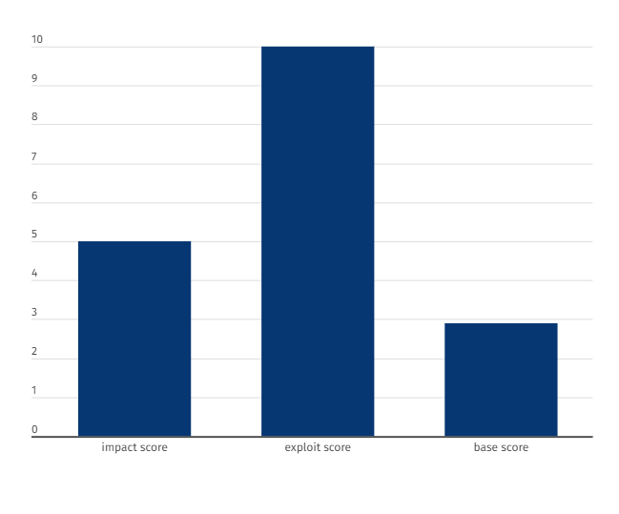

Figure: Graphical representation of score of vulnerability

2.9

10

5

* 1. Challenges In Implementing Comprehensive And Detailed Reporting

Implementing comprehensive and detailed reporting can present several challenges that organizations need to address to ensure the effectiveness and usefulness of the reports. Some of the main challenges include:

* Data Collection and Quality: Gathering relevant and accurate data from various sources can be challenging. Incomplete or inconsistent data can lead to inaccurate analysis and insights.
* Data Integration: Integrating data from different systems and departments may be complex, especially when dealing with diverse data formats and structures.
* Time and Resources: Preparing comprehensive reports can be time-consuming and resource-intensive, particularly for organizations with limited personnel and tight schedules.
* Data Privacy and Security: Ensuring data privacy and security is critical, especially when handling sensitive or confidential information. Proper data anonymization and access controls are essential.
* Understanding Audience Needs: Tailoring the report to meet the specific needs of different stakeholders and audiences requires a deep understanding of their requirements and preferences.
* Visual Representation: Choosing the appropriate data visualization techniques to effectively communicate complex information and insights may be a challenge.
* Scope and Relevance: Striking the right balance between including sufficient detail and maintaining relevance can be difficult, as overly detailed reports may overwhelm readers.
* Maintaining Consistency: Standardizing reporting formats and templates across various reports can be challenging in large organizations.
* Version Control: Ensuring that reports reflect the most recent data and updates can be difficult, especially in rapidly changing environments.
* Lack of User Engagement: If reports are not engaging or easily accessible, stakeholders may not use them effectively.
* Interpretation and Actionability: Presenting data in a way that is easy to interpret and actionable is crucial. Without clear insights and recommendations, the report's value diminishes.
* Balancing Automation and Human Input: Automating the reporting process can streamline efforts, but human expertise is still needed to interpret results and add context.

6.5 Impact of comprehensive and detailed reporting on decision-making

Cyber incident reporting is when an organization that has been affected by a [cyber attack](https://www.upguard.com/blog/cyber-attack" \t "_blank), [data breach](https://www.upguard.com/blog/data-breach), [data leak](https://www.upguard.com/blog/data-leak), or any situation where [sensitive information](https://www.upguard.com/blog/sensitive-data) was exposed, reports the incident to the proper parties, which typically include stakeholders, law enforcement, affected customers, business partners, and government officials.

Incident reports typically include details of the incident, including when it happened, how it occurred, who or what was affected, and the scope of the breach. The report is then used to assess the incident, in which the information is used to determine new security policies, compliance standards, or other risk management strategies.

## The Importance of Cyber Incident Reporting

Incident reporting is important because it provides a way for organizations and businesses to document, respond, and learn from a cyber attack. Incident reporting should be part of every organization’s security program as part of the [incident response process](https://www.upguard.com/blog/incident-response-plan).

Additionally, security incident reporting should be done as soon as the attack has been detected, with all affected and related parties notified immediately. In many cases, businesses or individuals fail to do so out of embarrassment or fear that they will lose customer trust. However, the faster an incident is reported, the faster officials and authorities can support you or your organization in responding to the attack.

Here are the top reasons why organizations need to report cyber incidents.

### Maintain Regulatory Compliance

Federal laws, such as the [Cyber Incident Reporting for Critical Infrastructure Act of 2022 (CIRCIA)](http://www.upguard.com/blog/circia) or [GDPR](https://www.upguard.com/blog/how-to-be-gdpr-compliant), require critical infrastructure organizations to report incidents promptly, no later than 72 hours after the incident. Cyber incident reporting is also mandatory in highly-regulated sectors, such as [healthcare](https://www.upguard.com/blog/healthcare-prevent-data-breaches) and [finance](https://www.upguard.com/blog/cybersecurity-regulations-financial-industry), and failure to do so often results in costly penalties.

All organizations facing regulatory scrutiny for [data protection](https://www.upguard.com/blog/data-security) need appropriate [monitoring systems](https://www.upguard.com/blog/compliance-monitoring), reporting processes, documented [incident response plans](https://www.upguard.com/blog/incident-response-plan), and disaster recovery plans to help diagnose, contain, and repair the damage.

The goal of these federal mandates isn’t to punish respective businesses for failure to secure their systems, but to “**enhance the situational awareness of cyber threats**” and “**facilitate information sharing**” for all businesses and governments. They encourage non-covered entities (non-infrastructure, private organizations) to voluntarily report all incidents to better understand the latest cyber threats and to advance new initiatives aimed to protect [sensitive data](https://www.upguard.com/blog/sensitive-data).

### Improve Risk and Threat Awareness

Cyber incident reports aren’t just documentation of a particular cyber attack — they can also serve as a framework for other businesses to learn from and improve their [risk management programs](https://www.upguard.com/blog/it-risk-management). In the world of [cybersecurity](https://www.upguard.com/blog/cyber-security), all businesses should be working together to fight against cybercrime and limit the scope of attacks from threat actors.

In many cases, the business or individual has no realization or understanding of the cyber attack and fails to report it entirely. The more the incident is reported in the media, the higher likelihood that more individuals will recognize signs of a [cyber attack](https://www.upguard.com/blog/cyber-attack" \t "_blank) and hopefully begin to improve their personal and professional cybersecurity practices.

A full incident report also helps IT professionals better understand [the cyber threat landscape](https://www.upguard.com/blog/cyber-threat-landscape) and how to mitigate new cyber risks. Especially if a business suffered a [zero-day vulnerability](https://www.upguard.com/blog/zero-day), the incident report could detail the nature of the [vulnerability](https://www.upguard.com/blog/vulnerability), how it was exploited, and what patches are needed to resolve the vulnerability.

### Build Trust With Clients, Customers, and Stakeholders

Any business handling customer data should take care to protect its customers and ensure that their information is safely secured. This includes being transparent and honest when they have experienced a [data breach,](https://www.upguard.com/blog/data-breach) regardless of the cause of the incident. Reporting a cyber incident can build trust with the organization’s patients, clients, customers, and stakeholders that they are handling the incident with professionalism and urgency.

Although the [cyber attack](https://www.upguard.com/blog/cyber-attack" \t "_blank) may initially be frowned upon or criticized, organizations need to remember that no business in the world is completely protected against threats and that even the largest corporations suffer security breaches.

### Protect Business Relationships

An organization’s [attack surface](https://www.upguard.com/blog/attack-surface) includes its [third-party service providers](https://www.upguard.com/blog/five-things-to-know-about-third-party-risk). Any organization that has suffered a cyber incident needs to report it to all of its business partners to ensure that they are also protecting themselves. No matter how well organizations are secured internally, a breached external third party could still potentially compromise their entire network.

More importantly, failure to report an incident could also affect business relationships negatively and potentially throughout the entire industry since the affected organization can put the entire [supply chain](https://www.upguard.com/blog/what-is-supply-chain-risk-management) at risk, including all third and [fourth parties](https://www.upguard.com/blog/what-is-fourth-party-risk).

### Ensure Prompt Remediation Action

Many reporting requirements require a swift and thorough diagnosis of the incident after it has occurred. Although in many cases, data breaches are not detected until a few months after it has happened, the moment it has been detected, incident response plans detailing reporting processes should be triggered immediately.

Once the incident is reported, the organization is on record and required to follow up regarding containment and [mitigation](https://www.upguard.com/blog/reduce-cybersecurity-risk) steps. Additionally, federal agencies, such as the Information Commissioner’s Office (ICO) or the Office for Civil Rights (OCR), can often provide additional resources to help the organization respond to the attack.

This process can help individuals and organizations avoid cyber threats in the future by performing a full (and in some cases mandated) investigation on how and why the incident occurred.

## When to Report a Cyber Incident

While having as much information as possible about the cyber incident will facilitate getting help, organizations should report cyber incidents promptly within a certain timeframe (usually within 72 hours), even if not all the information is available. A company may report multiple times as the situation evolves, and it’s better to start this process sooner rather than later so the organization can alert all affected parties.

[According to the Department of Homeland Security (DHS)](https://www.dhs.gov/sites/default/files/publications/Cyber%20Incident%20Reporting%20United%20Message.pdf), victims of cybercrime are encouraged to report cyber incidents as soon as possible if there is a chance of the following:

* Significant [loss of data](https://www.upguard.com/blog/data-loss-vs-data-leaks), information system availability, or control
* A substantial number of affected people
* [Unauthorized access](https://www.upguard.com/blog/access-control) to critical information technology systems
* [Malicious software](https://www.upguard.com/blog/types-of-malware) on critical IT systems
* Compromise of core government functions or critical infrastructure
* Compromise of public health and safety, national security, or economic security

6.6 Best practices for creating comprehensive and detailed reports

#### General Approach to Creating the Report

1. Analyze the data collected during the assessment to identify relevant issues.
2. Prioritize your risks and observations; formulate remediation steps.
3. Document the assessment methodology and scope.
4. Describe your prioritized findings and recommendations.
5. Attach relevant the figures and data to support the main body of your report.
6. Create the executive summary to highlight the key findings and recommendations.
7. Proofread and edit the document.
8. Consider submitting the report draft to weed out false positives and confirm expectations.
9. Submit the final report to the intended recipient using agreed-upon secure transfer mechanism.
10. Discuss the report's contents with the recipient on the phone, teleconference, or in person.

#### Analysis of the Security Assessment Data

* Share your insights beyond regurgitating the data already in existence.
* Consider what information provided to you is incomplete or might be a lie or half-truth.
* Look for patterns by grouping your initial findings by the affected resources, risk, issue category, etc.
* Identify for trends that highlight the existence of underlying problems that affect security.
* If examining scanner output, consider exploring the data using spreadsheets and pivot tables.
* Fill in the gaps in your understanding with follow-up scans, documentation requests, and interviews.
* Involve colleagues in your analysis to obtain other people's perspectives on the data and conclusions.

#### Assessment Methodology Documentation

* Document the methodology used to perform the assessment, analyze data, and prioritize findings.
* Demonstrate a systemic and well-reasoned assessment and analysis approach.
* Clarify the type of the assessment you performed: penetration test, vulnerability assessment, code review, etc.
* If applicable, explain what tools you used and how they were configured.
* If applicable, describe what approach guided the questions you asked during interviews.
* Describe the criteria you used to assign severity or critical levels to the findings of the assessment.
* Refer to the relevant frameworks you used to structure the assessment (PCI DSS, ISO 27001, etc.).

#### Scope of the Security Assessment

* Specify what systems, networks and/or applications were reviewed as part of the security assessment.
* State what documentation you reviewed, if any.
* List the people whom you interviewed, if any.
* Clarify the primary goals of the assessment.
* Discuss what contractual obligations or regulatory requirements were accounted for in the assessment.
* Document any items that were specifically excluded from the assessment's scope and explain why.

#### Documenting Conclusions

* Include both negative and positive findings.
* Account for the organization's industry, business model, and compliance requirements.
* Stay consistent with the methodology and scope.
* Prioritize findings related to security risks and remediation steps.
* Provide a practical remediation path, accounting for the organization's strengths and weaknesses.

#### Qualities of a Good Assessment Report

* Open with a strong executive summary that a non-technical reader can understand.
* Provide meaningful analysis, instead of merely presenting the output of assessment tools.
* Include the figures to support your analysis, placing non-critical information in the appendix.
* Craft a professional, easy-to-follow look.
* Offer remediation guidance beyond merely pointing out security problems.
* Find and fix your typos. Ask for help, if you can.
* Structure the report in logical sections to accommodate the different types of readers.

#### Additional Assessment Report Tips

* Create templates based on prior reports, so you don't have to write every document from scratch.
* Safeguard (encrypt) the report when storing and sending it, since its contents are probably sensitive.
* Use concrete statements; avoid passive voice.
* Explain the significance of your findings in the context of current threats and recent events.
* Put effort into making the report as brief as possible without omitting important and relevant contents.